# *The Penguin Project* student booklet

# Your name: ___________________________________________

Fred the penguin is very young. He doesn’t know how to survive the bitterly cold winter in the Antarctic. Temperatures there reach well below freezing point.

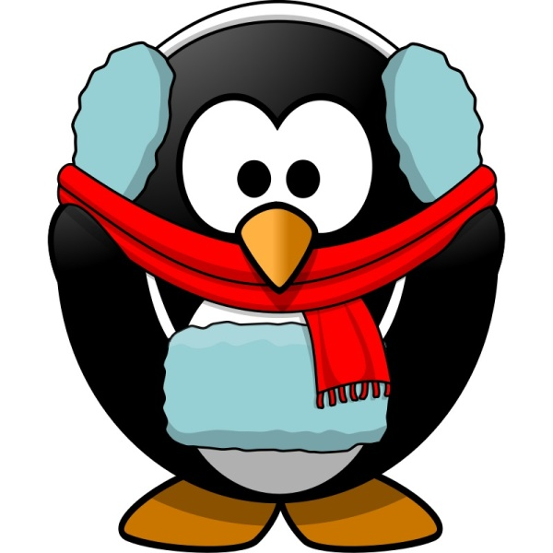

Fred

In this project you will find out answers to these questions:

* Why does a penguin need to stand in a group to stay warm?
* What kind of body covering should a penguin ‘wear’ to keep warm?

**Let’s learn more about penguins…**

Circle the correct answers below as we watch the David Attenborough video.

1) What is the temperature in winter in the Antarctic where the penguins live?

- 40°C - 10°C - 70°C

2) Why do the Emperor penguins huddle together?

To survive To eat To wash

3) Where should a penguin stand in the huddle to be the warmest?

On the side In the middle Don’t know

4) Do the penguins always stay in the same place in the huddle?

Yes No Maybe Don’t know

5) In mid-winter there is one month of:

total darkness total daylight constant snow

6) How long as it been since the penguins have eaten at the end of winter?

7 days 115 days 200 days

**Investigation 1: The penguin huddle**

Let’s see where a penguin will keep the warmest in a group.

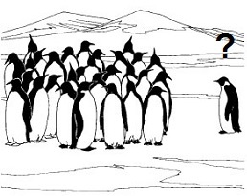

**Equipment needed**

7 cans 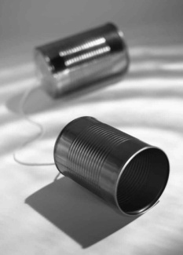 warm water C:\Users\Craig\AppData\Local\Microsoft\Windows\Temporary Internet Files\Content.IE5\35LS4AIE\MC900215338[1].wmf

[](http://www.google.co.uk/imgres?imgurl=https://cdn.media34.whipplehill.net/ftpimages/410/push/17770/thermometer_clipart.gif&imgrefurl=http://www.spes.org/podium/push/default.aspx?s=410&i=17770&usg=__xOlw8VmW_831QcCqaFu6ihNDwFA=&h=364&w=269&sz=5&hl=en&start=18&zoom=1&tbnid=opsVGIry9_HLgM:&tbnh=121&tbnw=89&ei=mZbIT65llIzTBYHsqMcB&prev=/search?q=thermometer+clip+art&um=1&hl=en&tbm=isch&um=1&itbs=1)7 thermometers a stopwatch, clock or timer

C:\Users\Craig\AppData\Local\Microsoft\Windows\Temporary Internet Files\Content.IE5\Q66E37R0\MC900217584[1].wmf

1 marking pen

**Planning**

**Choose the best words to fill in the blanks in the sentences below:**

***temperature cans***

***stopwatch***

***warm penguin***

For my experiment I have 7 ____________________ .

Each ‘can’ represents a __________________. I will put them in a group to see where a penguin should stand to keep __________________.

To measure the ___________________ I will use a thermometer.

To measure the time I will use a ____________________.

**What I will do**

**Work out the correct sequence of steps for your investigation.**

**The number ‘1’ shows the first step but the others are jumbled. Put number ‘2’ in the box for the next step then keep going until all the steps are in the correct order.**

|  |  |  |
| --- | --- | --- |
| 1 |  | Collect all the equipment |
|  |  | Record the temperatures after 5 minutes |
|  |  | Read the starting temperature of each can |
|  |  | Record the temperatures after 10 minutes |
|  |  | Put the cans in a group with can G in the centre |
|  |  | Fill the cans to the top with warm water |
|  |  | Label the cans A-G |
|  |  | Add the thermometers |

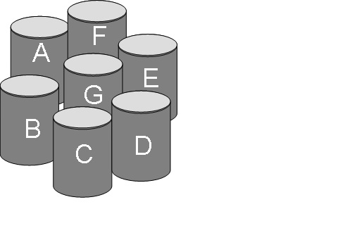

Don’t forget to put a thermometer in each can

**Recording**

You will need to record:

* starting temperatures
* temperature after 5 minutes
* temperature after 10 minutes

|  |  |  |  |
| --- | --- | --- | --- |
| **Can** | **Starting temperature (°C)** | **Temperature after 5 minutes (°C)** | **Temperature after 10 minutes (°C)** |
| A |  |  |  |
| B |  |  |  |
| C |  |  |  |
| D |  |  |  |
| E |  |  |  |
| F |  |  |  |
| G |  |  |  |

**Looking at results**

Write the number of the can that stayed the warmest? ___

Which can lost the most heat? ___

**Circle the penguin that will be warmer than the others.**

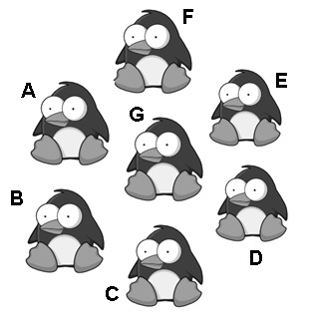

Penguin ____ kept warmer than the other penguins, because ________________________________________

________________________________________________________________________________________________

To show this, I used 7 ________ and I put warm ___________ inside them. I measured the temperatures of each can after _____ and _____ minutes.

**Investigation 2: What kind of body covering** **should a penguin ‘wear’ to keep warm?**

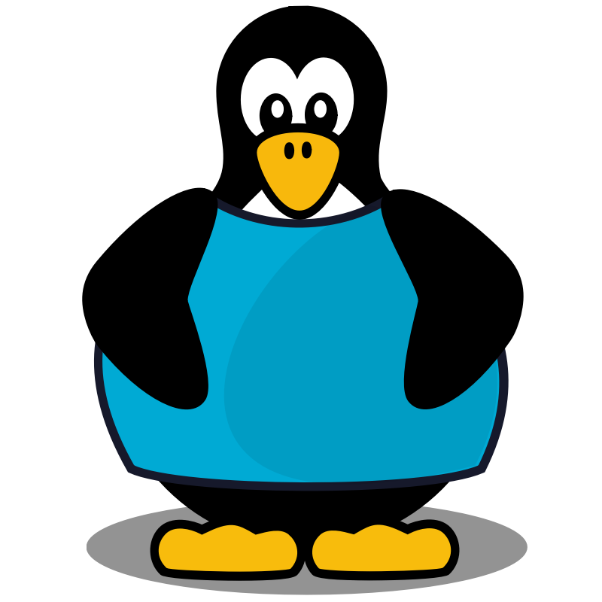

**Penguins are covered in a thick layer of fat under their skin. They also have fine feathers to trap heat in their bodies. Things that trap heat are insulating materials. Materials that carry heat away are called conductors of heat.**

**Circle all words below that are metals:**

Iron Wool Copper Wood

Paper Tin Gold Plastic

Silver Nickel Glass Lead

* **Metals** are good **conductors** of heat, that’s why they are used to make frying pans and cooking pots.
* **Plastic** is a good **insulator**, that’s why it is used to make the handle on cooking pots (so you won’t burn your hand!!)

**Draw a frying pan or cooking pot in the box below and label each part with the material it is made from.**

**Investigation planner**

**Which material is the best insulator?**

We are going to investigate which type of material is best for preventing heat loss from warm water inside a can. We will dress up our cans in different materials and see which can stays the warmest over time.

**What materials have you chosen?**

|  |
| --- |
|  |

**My question is:**

Which material is the best insulator?

**My prediction is:**

|  |
| --- |
|  |

**Choosing variables:**

|  |  |
| --- | --- |
| **I will change:** | **I will measure:** |
|  |  |

**I will not change (so that it is fair):**

|  |
| --- |
|  |

|  |  |  |  |  |  |  |  |  |  |  |  |  |  |  |  |  |  |  |
| --- | --- | --- | --- | --- | --- | --- | --- | --- | --- | --- | --- | --- | --- | --- | --- | --- | --- | --- |
| **What I will do:**  **Work out the correct sequence of steps for your investigation.**  **The number ‘1’ shows the first step but the others are jumbled. Put number ‘2’ in the box for the next step then keep going until all the steps are in the correct order.**   |  |  |  | | --- | --- | --- | | 1 |  | ‘Dress up’ your can | |  |  | Record the temperature after 5 minutes | |  |  | Read the water’s starting temperature | |  |  | Record the temperature after 10 minutes | |  |  | Add the thermometer | |  |  | Fill the can with warm water |   **Draw a labelled diagram of your ‘dressed up’ can.** |

### 

### Recording results:

You will need to record the:

* material used to ‘dress up’ the can
* starting temperature
* temperature after 5 minutes and after 10 minutes

|  |  |  |  |
| --- | --- | --- | --- |
| **Material** | **Starting temp (°C)** | **Temp after 5 minutes (°C)** | **Temp after 10 minutes (°C)** |
|  |  |  |  |
|  |  |  |  |
|  |  |  |  |
|  |  |  |  |
|  |  |  |  |
|  |  |  |  |

**Discussing results**

**Question:** Which material was the best insulator?

**Claim:**

|  |
| --- |
|  |

**Evidence:**

|  |
| --- |
|  |

**Would you choose this material to stop you losing heat on a cold day? Why/Why not?**

|  |
| --- |
|  |

### 

**Doodle page**

Not sure what to do? Draw a nice warm penguin here…