Activity station 1

Make a magnet

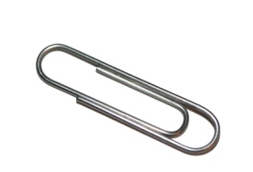
You will need:
- a magnet
- several paper clips

What to do
- See if any of the paper clips have magnetic properties, by testing whether the paper clips are attracted to each other. Only use the paper clips without magnetic properties.

- Stroke a paper clip several times in the same direction with a strong magnet. It is important to make sure each stroke is in the same direction. This turns it into a temporary magnet.

- Test the magnetised paper clip by seeing if a non-magnetised paper clip is attracted to it. (Hint: If there is no attraction, try stroking the magnetised paper clip a few more times.)
- How many strokes did it take for the paper clip to become magnetised?
- Do more strokes make the paper clip’s magnetism stronger?
- What do you think might take away the magnetic properties? Try your ideas. Did they work?
- Can you re-magnetise the paper clip again?

Record what you try and what you find out.

Activity station 1a

Make a compass

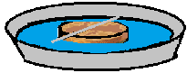
You will need:
- a straightened paper clip
- a flotation disc. Place a mark on the edge with a pen.
- a magnet
- a bowl of water

What to do
- Magnetise the straightened paper clip by stroking it several times in the same direction with the magnet. It is important that each stroke is in the same direction.

- Place the floating disc in the middle of a bowl with about 2–3 cm of water.

- Rest the magnetised paper clip on the disc, so that one end is near the mark you made.

Notice which way the paper clip is pointing when it stops moving.
What happens if you:
- turn the paper clip so it points another way?
- put the disc on the table instead of floating it in the water?

What else could you try?
Record what you do and what you find out.

Activity station 2

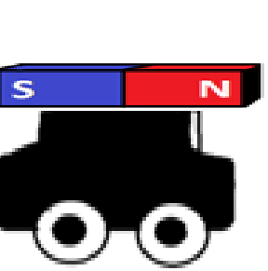
Attraction and repulsion – magnet cars

You will need:
- 2 bar magnets
- 2 plastic toy cars
- tape

What to do
- Tape one magnet onto each car to investigate what happens when the magnets face different ways.

- Can you make a rule that would explain what happens and why?

- Think of how you might test your rule?

Record what you try and what you find out.

Activity station 3

Levitating ring magnets

You will need:
- 3 or more ring magnets
- a pencil

What to do
- Stack the magnets onto the pencil and notice what happens.

- What happens when the magnets are reversed?

- Can you make a rule that would explain what happens and why?

- Think of how you might test your rule.

Record what you try and what you find out.

Activity station 4

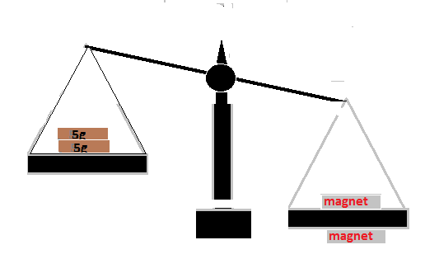
How strong is a magnet?

You will need:
- a balance scale
- weights
- tape
- 3 or more magnets
- counters (spacers)

What to do
- Tape one magnet (A) to a desk and place another magnet (B) on one of the balance baskets. Position the balance basket with the magnet over the top of the magnet you have taped to the desk. Ensure they are 'attached' (see the diagram above).

- Carefully place one weight at a time on the other balance basket unit the magnets separate. Place the weights gently so that the force of placing in the weights does not affect the pull.

- Repeat with a different number of magnets.

- Compare and record the strength of different magnets.

- How could you find out whether 2 magnets in the basket are stronger than one?

- Discuss with your group: Why would dropping the weights in the basket not be a fair test?

- What other things do you notice? What is the effect of placing a spacer between magnet A and B?

- Create a way to record data and observations.

Activity station 5

What can magnetic force pass through?

You will need:
- a magnet
- a piece of cardboard
- other materials/objects
- a paper clip
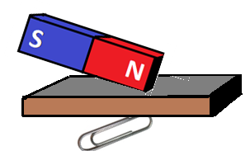

What to do
- Place a magnet on one side of a piece of cardboard, and a paper clip on the other (see diagram above).

- Can the magnetic force pass through the cardboard to move the paper clip?

- How far away can the magnet be from the cardboard and still have an effect?

- What other materials can you try? What other materials can the magnetic force pass through?

- Can a magnetic force pass through your hand? Can it pass through 2 hands?

- Record what you try and what you find out.

