Building virtual circuits
http://www.cleo.net.uk/consultants_resources/science/circuitWorld/index.html
This website will allow you to explore how circuits work, and the symbols that are used to drawn to represent each part of the circuit.
At the base of the screen are three symbols.

Circuit symbols Animated characters Circuit pictures
Click on the ‘circuit pictures’ to obtain the screen shown below.
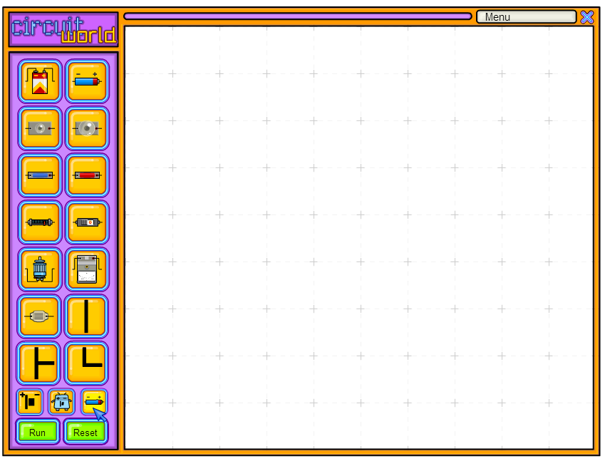
Click on the large battery and place it in the centre of the screen. Connect wires to the battery so that you create the diagram below.
(HINT: The corner wires rotate on the spot by clicking repeatedly.)
Click on the run button at the bottom of the panel. Does the light work? Why or why not?
Complete the circuit by adding a straight wire. Can you turn on the light now?
Click on the circuit symbols at the bottom of the screen. This replaces the pictures with the electrical symbols.
Draw the symbol that replaced;
(i) the battery (ii) the light (iii) the wires

Current is a measure of how fast electrons through the wires. One ampere represents one electron flowing past a point every second. Current is measured using an ammeter.
Remove one of the wires and replace it with the ammeter.

Circle the symbol that represents the ammeter above.
Run the circuit. What is the ammeter reading for that part of the circuit? ___________ amps
Shift the ammeter to the other side of the circuit.
Run the circuit. What is the ammeter reading for that part of the circuit? ___________ amps
Has the lamp affected how fast the electrons move?

Add a resistor into the circuit. (Circle the symbol for a resistor below.)

Run the circuit. What effect did the resistor have on the current?

Describe this in terms of the movement of electrons through the wires.

Build the circuits in the diagrams below.
For each circuit in A and B;
- Describe what the circuit does
- Draw the circuit symbols
- Describe what is happening to the current.
A
B
C What happens when a second light is added to this circuit? Draw the circuit below.
D Write the current readings next to all these ammeters.
E Write the amount of current next to all the ammeters.
F Replace the resistor with a wire. Draw the circuit. What happens to the current?

G Imagine the electrons moving through the wire just like students moving down a corridor at school. How could you represent a resistor in this situation?

H Why would a resistor be needed in a circuit?

