Name ____________________________________________________________ Date ________________________________ Class _________

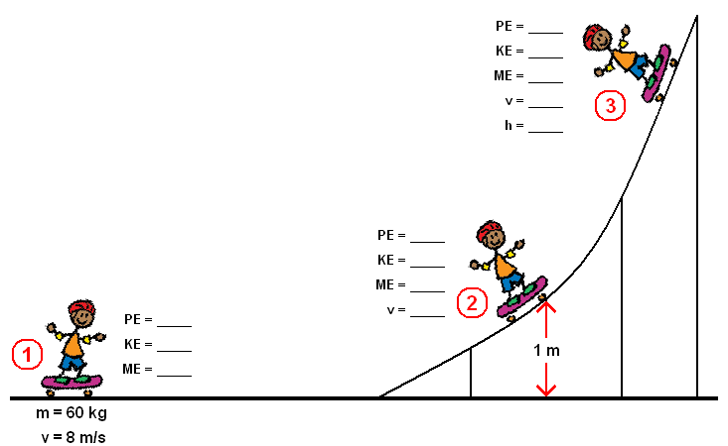
PHYSICAL SCIENCE WORKSHEET

GPE = 15 J
KE = ____
ME = ___
CONSERVATION OF ENERGY #1
(use g = 10 m/s² for all calculations)

- Fill in the missing values. Assume no energy losses due to friction.

GPE = ____
KE = 7 J
ME =____

GPE = 0 J
KE = ____
ME = 15 J

- Fill in the missing values. Assume no energy losses due to friction. The data relates to a 0.5 kg object at each position.
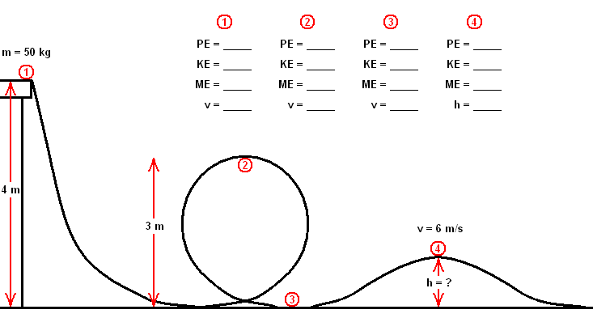
1 m
GPE =
KE =
ME =
GPE =
KE = 20 J
ME =
GPE =
KE =
ME =
GPE = 20 J
KE = 0 J
ME =

- A 1.8 kg book has been dropped from the top of the football stadium. Its speed is 4.8 m/s when it is 2.9 metres above the ground. What is its mechanical energy?

- A 28 kg child on a swing is travelling at 4.2 m/s. What is his gravitational potential energy if he has 315 J of mechanical energy?

- Identical twins Rick and Chris are painting a house. Rick is standing on the scaffolding 5 metres above the ground. Chris is standing on the scaffolding 5 metres above Rick. Who has more gravitational potential energy? Explain your answer.

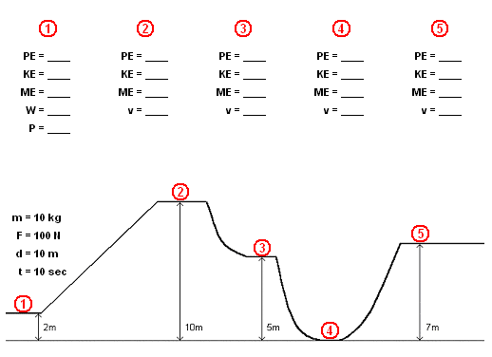
- Fill in the missing values. Assume no energy losses due to friction. The data relates to a 2 kg object at each position.
GPE =
KE =
ME =
GPE =
KE =
ME =
GPE =
KE =
ME =
GPE =
KE =
ME =
GPE =
KE = 170 J
ME =

- John has 200 Joules of gravitational potential energy when he is standing still on a diving board.

  - Find his mechanical energy.

  - John jumps off the diving board. What is his gravitational potential energy when he is halfway to the water?

  - What is his mechanical energy when he lands in the water?

- A ball has a 17 J of kinetic energy and its mechanical energy is 25 J.

  - Find the gravitational potential energy of the ball.

  - If the ball has a mass of 3.2 kg, what is its height above the ground?

  - What is the speed of the ball?

- What is the mass of a child that has a KE of 400 J who is riding her bike at 3.9 m/s?

- Jared and Clay are climbing the stairs. Jared gets tired and stops halfway to the fourth floor. Clay makes it to the fourth floor without a problem. If Jared is twice as heavy as Clay, who has more gravitational potential energy? Explain your answer.

