Name and nature of activity | Performing a lung dissection
Location and date of activity
Name of teacher/technician
Activity type | Technician procedure Teacher demonstration Student activity – Student year group
Physics and general equipment | Type of hazard |  |  | Controls and other measures
PPE (lab coat/apron, safety glasses and gloves)  Dissecting board  Dissecting instruments: Forceps, Probe, Scissors, Scalpel (optional)  Glassware, tubing and string  Pump or syringe  Large, transparent, plastic bag  Paper towelNewspaper | Radiation 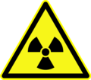 ionising laser  Electrical 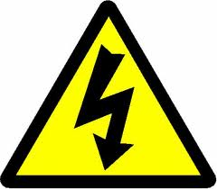  Thermal  Projectiles  Sharps  Other – |  |  | Relevant signage  Perspex safety shield  Sharps container  Glassware free from cracks or chips  Safety glasses  Thermally insulated gloves  Other – Only staff attach/remove scalpel blades, using safe procedures or use disposable scalpel blades.
Chemicals used and produced | Type of hazard |  |  | Controls and other measures
Disinfectant – hospital grade, diluted according to manufacturer’s instructions  (Corrosive)  70% v/v ethanol (flammable) | 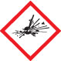 Explosive  Flammable  Oxidising  Gases under pressure  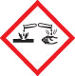 Corrosive |  | 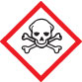 Acute toxicity  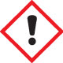 Health hazards  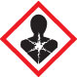 Chronic health hazards  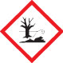 Environmental  Other – | Limit quantity/concentration  Perspex safety shield  Ventilation: natural/exhaust  Fume cupboard  Safety glasses  Laboratory coat/apron  Gloves: latex/nitrile/neoprene/PVC  Safety shower  Other –
Biological/geological materials | Type of hazard |  |  | Controls and other measures
Fresh sheep, cow or pig heart-lung set (pluck) | Biohazard 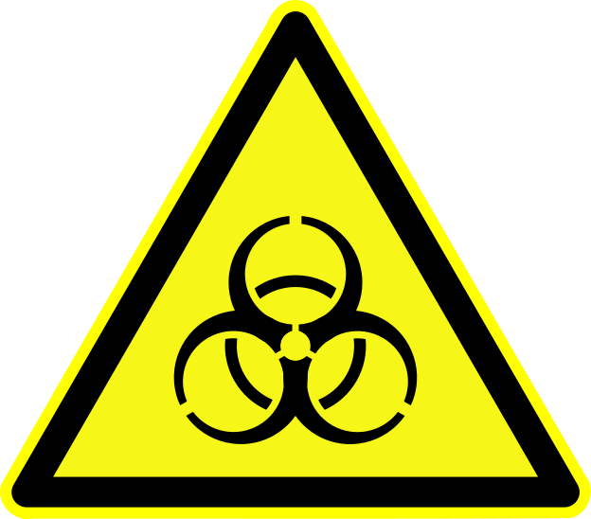  Dust/aerosols  Sharps  Manual handling 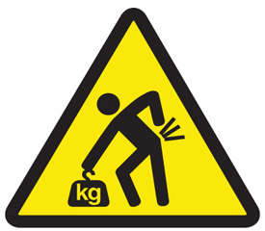  Other – |  |  | Steriliser  Disinfectant  Sharps container  Dust mask  Safety glasses  Gloves  Other – Use plastic bag when inflating lungs
Waste produced | Waste disposal procedure
Dissected animal tissue lung (pluck )(bin)  Used disinfectants (sink)  Used or damaged scalpel blades | Pre-treatment of waste – All parts of the lung must be wrapped in newspaper and placed in a dedicated garbage bag.When waste is collected double bag for disposal in industrial bin.  Sink with water – Used disinfectants  Regular waste – Dissected animal tissue (lungs)  Licenced hazardous waste company –  Other – Used/damaged scalpel blades must be placed in an approved sharps container after use.
Standard Operating Procedures
I have read the relevant Standard Operating Procedure.
I am experienced/trained in using all the equipment listed.
All chemicals used and produced are approved for use.
I have read the current SDSs for all hazardous chemicals used and produced.
I am aware of safety guidelines for using all chemicals, materials and equipment.
I will follow local guidelines for waste disposal (water authority, local council, EPA).
I am aware of first aid procedures if required.
Other comments: Note that fainting may occur during this type of activity, so be familiar with first aid information. Offal that has passed a health inspection by a health inspector or procured from a butchers shop, abattoir or biological supplier is suitable for dissection.Store below 5°C prior to dissection. Use dissection scissors, instead of scalpels for students whenever possible.
Conclusion:
Risks not significant now and not likely to increase.
Risks significant but effectively controlled at the moment.
Risks significant and not adequately controlled at the moment.
Uncertain about risks; more detailed assessment required.
Assessment carried out by: |  | Signature: |  |  | Date:
Assessment approved by: |  | Signature: |  |  | Date:
Next assessment due:
This Risk Assessment assumes that the activity will be conducted in a science teaching area with the following facilities: electricity, running water, emergency shut-offs for electricity, gas if applicable, and water, regular testing and tagging of portable appliances; emergency contingencies such as evacuation/emergency plans, appropriate fire extinguishers, spill kits, hand washing facilities, eyewash/safety shower and first aid supplies. It is also assumed that all the necessary licencing requirements and approvals are obtained prior to the activity.

