Name and nature of activity | Diluting concentrated hydrochloric acid
Location and date of activity
Name of teacher/technician
Activity type | Technician procedure Teacher demonstration Student activity – Student year group
Physics and general equipment | Type of hazard |  |  | Controls and other measures
Magnetic stirrer (optional)  Glassware | Radiation 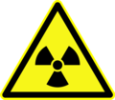 ionising 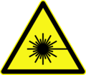 laser  Electrical 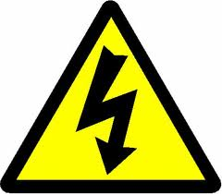  Thermal  Projectiles  Sharps  Other – |  |  | Relevant signage  Perspex safety shield  Sharps container  Glassware free from cracks or chips  Safety glasses  Thermally insulated gloves  Other –
Chemicals used and produced | Type of hazard |  |  | Controls and other measures
Hydrochloric acid, concentrated  Hydrochloric acid, dilute solution | 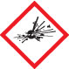 Explosive  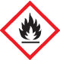 Flammable  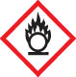 Oxidising  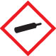 Gases under pressure  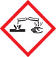 Corrosive |  | 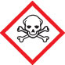 Acute toxicity  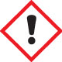 Health hazards  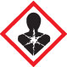 Chronic health hazards  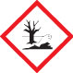 Environmental  Other – | Limit quantity/concentration  Perspex safety shield  Ventilation: natural/exhaust  Fume cupboard  Safety glasses  Laboratory coat/apron  Gloves: latex/nitrile/neoprene/PVC  Safety shower  Other – Ensure spill kit is available
Biological/geological materials used | Type of hazard |  |  | Controls and other measures
NA | Biohazard 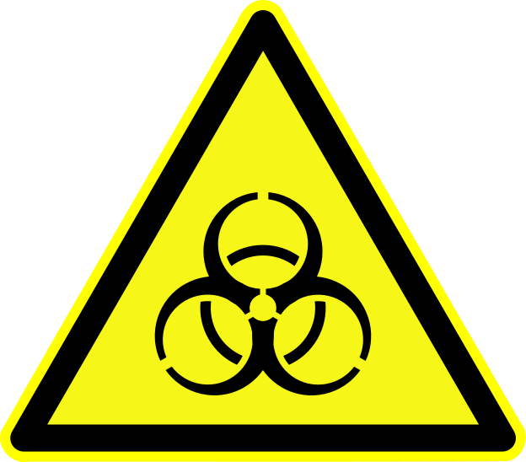  Dust/aerosols  Sharps  Manual handling 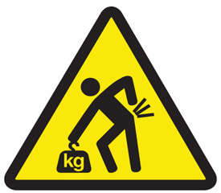  Other – |  |  | Steriliser  Disinfectant  Sharps container  Dust mask  Safety glasses  Gloves  Other –
Waste produced | Waste disposal procedure
Unused concentrated hydrochloric acid  Residual concentrated acid on glassware. | Pre-treatment of waste – If small quantity, neutralise first.  Sink with water – If small quantity, and after neutralisation.  Regular waste –  Licenced hazardous waste company – if large quantity  Other – Unused concentrated acid may be transferred to a suitable labelled container and stored for future use. Rinse contaminated glassware in fume cupboard before removal.
Standard Operating Procedures
I have read the relevant Standard Operating Procedure.
I am experienced/trained in using all the equipment listed.
All chemicals used and produced are approved for use.
I have read the current SDSs for all hazardous chemicals used and produced.
I am aware of safety guidelines for using all chemicals, materials and equipment.
I will follow local guidelines for waste disposal (water authority, local council, EPA).
I am aware of first aid procedures if required.
Other comments: If storing the unused concentrated acid, it is best transferred to a separate container to avoid contamination of the stock bottle.
Conclusion:
Risks not significant now and not likely to increase.
Risks significant but effectively controlled at the moment.
Risks significant and not adequately controlled at the moment.
Uncertain about risks; more detailed assessment required.
Assessment carried out by: |  | Signature: |  |  | Date:
Assessment approved by: |  | Signature: |  |  | Date:
Next assessment due:
This Risk Assessment assumes that the activity will be conducted in a science teaching area with the following facilities: electricity, running water, emergency shut-offs for electricity, gas if applicable, and water, regular testing and tagging of portable appliances; emergency contingencies such as evacuation/emergency plans, appropriate fire extinguishers, spill kits, hand washing facilities, eyewash/safety shower and first aid supplies. It is also assumed that all the necessary licencing requirements and approvals are obtained prior to the activity.

