Name and nature of activity | Using a laser
Location and date of activity
Name of teacher/technician
Activity type | Technician procedure Teacher demonstration Student activity – Student year group
Physics and general equipment | Type of hazard |  |  | Controls and other measures
Lasers | Radiation 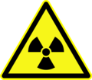 ionising 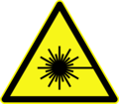 laser  Electrical 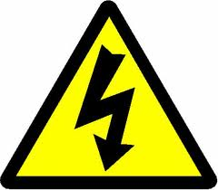  Thermal  Projectiles  Sharps  Other – |  |  | Relevant signage  Perspex safety shield  Sharps container  Glassware free from cracks or chips  Safety glasses  Thermally insulated gloves  Other – See comments below
Chemicals used and produced | Type of hazard |  |  | Controls and other measures
NA | 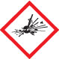 Explosive  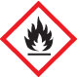 Flammable  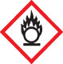 Oxidising  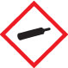 Gases under pressure  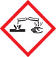 Corrosive |  | 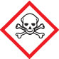 Acute toxicity  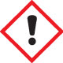 Health hazards  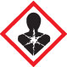 Chronic health hazards  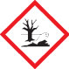 Environmental  Other – | Limit quantity/concentration  Perspex safety shield  Ventilation: natural/exhaust  Fume cupboard  Safety glasses  Laboratory coat/apron  Gloves: latex/nitrile/neoprene/PVC  Safety shower  Other –
Biological/geological materials used | Type of hazard |  |  | Controls and other measures
NA | Biohazard 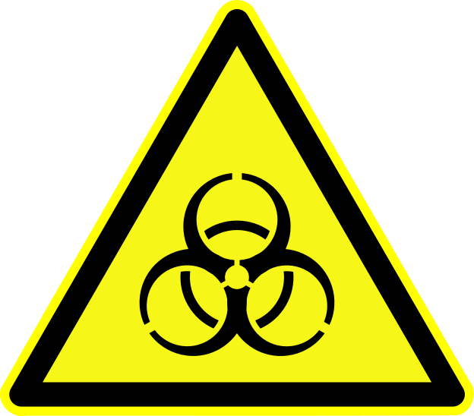  Dust/aerosols  Sharps  Manual handling 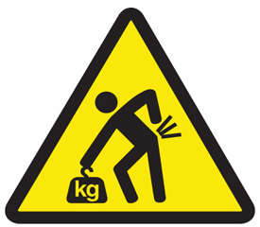  Other – |  |  | Steriliser  Disinfectant  Sharps container  Dust mask  Safety glasses  Gloves  Other –
Waste produced | Waste disposal procedure
NA | Pre-treatment of waste –  Sink with water –  Regular waste –  Licenced hazardous waste company –  Other –
Standard Operating Procedures
I have read the relevant Standard Operating Procedure.
I am experienced/trained in using all the equipment listed.
All chemicals used and produced are approved for use.
I have read the current SDSs for all hazardous chemicals used and produced.
I am aware of safety guidelines for using all chemicals, materials and equipment.
I will follow local guidelines for waste disposal (water authority, local council, EPA).
I am aware of first aid procedures if required.
Other comments: Controls: Limit to Class 2 Lasers; do not shine a laser at or near persons, do not dismantle lasers, do not use optical aids to view a laser beam. When not in use lasers should be stored in a locked cupboard. Lasers classified as Class 3R/ 3A, may only be used subject to gaining school permission and following good safety practices. If the class of any laser is not clearly identified then it should not be used.
Conclusion:
Risks not significant now and not likely to increase.
Risks significant but effectively controlled at the moment.
Risks significant and not adequately controlled at the moment.
Uncertain about risks; more detailed assessment required.
Assessment carried out by: |  | Signature: |  |  | Date:
Assessment approved by: |  | Signature: |  |  | Date:
Next assessment due:
This Risk Assessment assumes that the activity will be conducted in a science teaching area with the following facilities: electricity, running water, emergency shut-offs for electricity, gas if applicable, and water, regular testing and tagging of portable appliances; emergency contingencies such as evacuation/emergency plans, appropriate fire extinguishers, spill kits, hand washing facilities, eyewash/safety shower and first aid supplies. It is also assumed that all the necessary licencing requirements and approvals are obtained prior to the activity.

