The moon worksheet

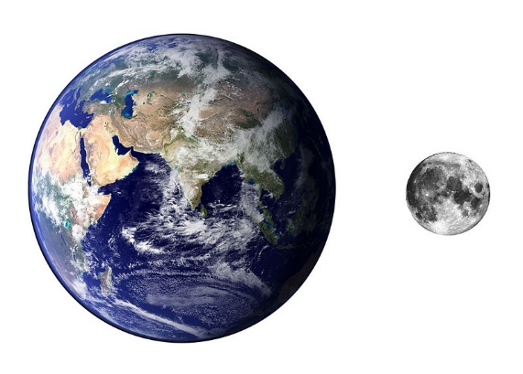
The moon has shone its light on the Earth for approximately 4.5 billion years. It lights our darkness and has been the source of many myths and omens. Ancient cultures recognized the regular movements of the moon and used them to plan their agricultural activities.
Lack of scientific knowledge, however, has led to many myths and legends about the moon. There have been many misconceptions about the dark side of the moon, but improvements in scientific understanding and space exploration has provided us with the answers to many of those questions.
https://commons.wikimedia.org/wiki/File:Earth_%26_Moon_compare_Image.jpg

Answer the following questions from the understanding you have gained from your problem-solving activity about the dark side of the moon.
- Where does the light we see coming from the moon come from?

- Explain why the moon has a day and night.

- How long is one day on the moon?

- How long does it take for the moon to make one complete revolution around the Earth?

Watch the video about the moon’s rotation then answer the remaining questions. https://www.youtube.com/watch?v=OZIB_leg75Q
- Examine the diagram to the right and explain what this diagram is showing about the moon’s movement around the Earth.
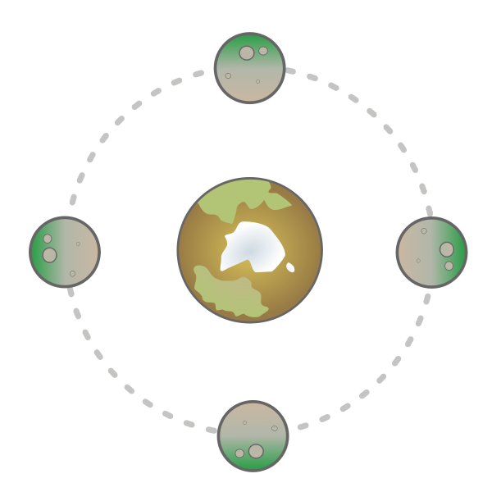
- Explain why there is no permanent dark side of the moon.

- Explain why there is a part of the moon we can never see.

EXTENSION: Watch the following video for a more in-depth
Wikimedia Commons. Smurrayinchester https://commons.wikimedia.org/wiki/File:Synchronous_rotation.svg CC BY SA 3.0
understanding of the moon’s movement around the Earth https://www.youtube.com/watch?v=6jUpX7J7ySo

The moon worksheet

The moon has shone its light on the Earth for approximately 4.5 billion years. It lights our darkness and has been the source of many myths and omens. Ancient cultures recognized the regular movements of the moon and used them to plan their agricultural activities.
Lack of scientific knowledge, however, has led to many myths and legends about the moon. There have been many misconceptions about the dark side of the moon, but improvements in scientific understanding and space exploration has provided us with the answers to many of those questions.
https://commons.wikimedia.org/wiki/File:Earth_%26_Moon_compare_Image.jpg

Answer the following questions from the understanding you have gained from your problem-solving activity about the dark side of the moon.
- Where does the light we see coming from the moon come from?
The light we see coming from the moon is actually light from the sun, which is reflected off the surface of the moon back towards the Earth.
- Explain why the moon has a day and night.
The moon has day and night because it rotates around its axis just like the Earth, so that half the moon is in sunlight while the other half of the moon is in darkness.
- How long is one day on the moon?
One day on the moon is 27 Earth days long.
- How long does it take for the moon to make one complete revolution around the Earth?
It takes 27 days for the moon to revolve around the Earth.

Watch the video about the moon’s rotation then answer the remaining questions. https://www.youtube.com/watch?v=OZIB_leg75Q
- Examine the diagram to the right and explain what this diagram is showing about the moon’s movement around the Earth.
This diagram shows that the same side of the moon is always facing the Earth.
- Explain why there is no permanent dark side of the moon.
Since the moon rotates on its axis the whole of its surface will eventually be in full sunlight.
- Explain why there is a part of the moon we can never see.
The moon rotates once on its axis in the same amount of time it takes to orbit the Earth. Therefore we always see the same side of the moon.
EXTENSION: Watch the following video for a more in-depth
understanding of the moon’s movement around the Earth https://www.youtube.com/watch?v=6jUpX7J7ySo
Wikimedia Commons. Smurrayinchester https://commons.wikimedia.org/wiki/File:Synchronous_rotation.svg CC BY SA 3.0

Problem solving scaffold

STEP | STUDENT NOTES
1) Identify questions that could be investigated.
2) Select ONE question to investigate.
3) Identify likely sources of information and equipment that could be used to answer the question.
4) Plan an investigation
5) Collect information
6) Evaluate the reliability of the information collected.

Dark side of the moon – STIMULUS MATERIAL

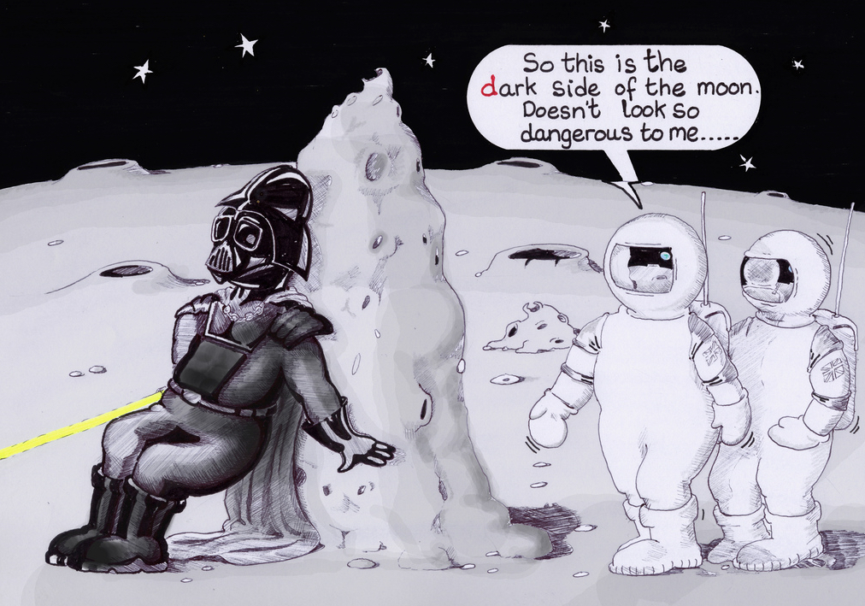© All rights reserved. Bubble-head, Flickr https://www.flickr.com/photos/plutosthebubbleman/3747014194/. Reproduced with permission

MISSION BRIEF: Explore the dark side of the moon

Phases of the moon
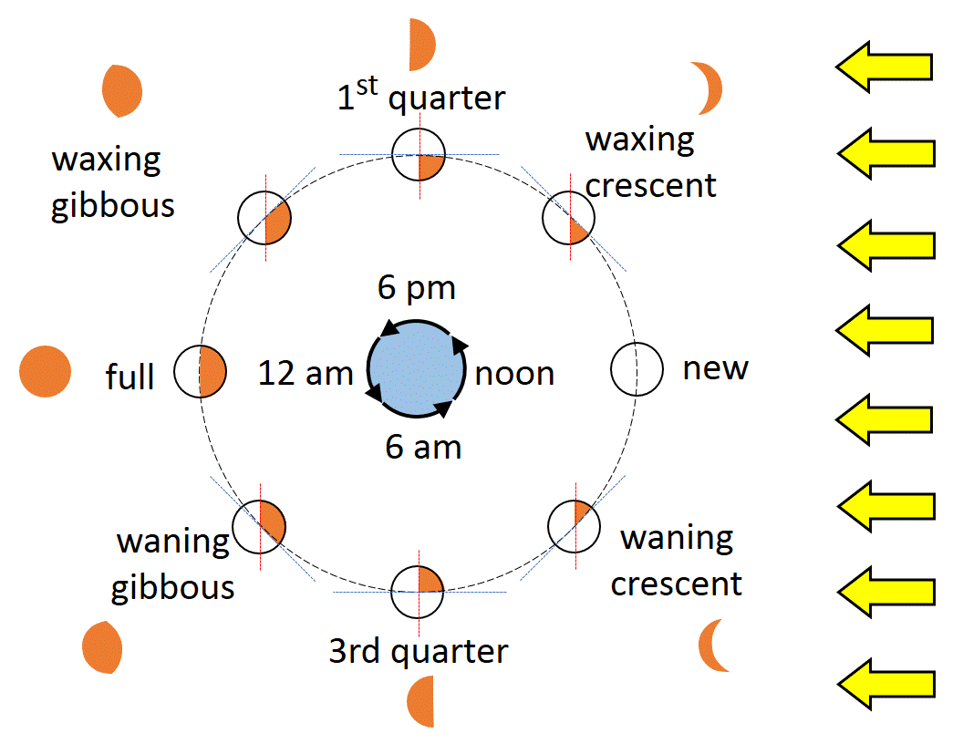

By Guy vandegrift (Own work) [CC BY-SA 3.0 (http://creativecommons.org/licenses/by-sa/3.0)], via Wikimedia Commons
Complete the cloze passage using the words provided in the box below.
As the moon _______ around the Earth, one ________ of the moon is _________ lit by _________ coming from the ______. As we can only view the ________ from the Earth, we cannot always ______ the whole lit _______ of the moon. ______ is why the _______ of the moon we see ______ each day. The shape we __________ is determined by the relative _________ of the sun, ________ and the ___________ on Earth.
constantly shape position light observe Earth revolves observer sun surface see changes moon This half

Answer the following questions:
- The new moon is often referred to as a ‘no moon’. Explain why we cannot see the moon at this particular time during its cycle.

- Why do we call the moon a ‘quarter moon’ when half of the moon is lit up by the sun?

- The moon is often said to be waxing or waning. Explain what is meant by these terms.

- Explain why the moon’s shape changes as it moves around the Earth.

- Cut and paste the phase pictures of the moon into the correct order beginning with the new moon. Label each shape with its correct name.
New Moon

Phases of the moon Answer sheet

By Guy vandegrift (Own work) [CC BY-SA 3.0 (http://creativecommons.org/licenses/by-sa/3.0)], via Wikimedia Commons

Complete the cloze passage using the words provided in the box below.
As the moon revolves around the Earth, one half of the moon is constantly lit by light coming from the sun. As we can only view the moon from the Earth, we cannot always see the whole lit surface of the moon. This is why the shape of the moon we see changes each day. The shape we observe is determined by the relative position of the sun, Earth and the observer on Earth.
constantly shape position light observe Earth revolves observer sun surface see changes moon This half

Answer the following questions:
- The new moon is often referred to as a ‘no moon’. Explain why we cannot see the moon at this particular time during its cycle.
We cannot see the moon as the sun is shining on the surface of the moon that is facing away from the Earth and toward the sun.
- Why do we call the moon a ‘quarter moon’ when half of the moon is lit up by the sun?
Even though the sun always lights up half of the moon’s surface, when the moon is positioned half way between the new moon and the full moon, the part of the moon's surface we can see is one quarter of the moon's surface.
- The moon is often said to be waxing or waning. Explain what is meant by these terms.
Waxing refers to the view of the moon’s shape as it is increasing in size and waning refers to the view of the moon’s shape as it is decreasing in size.
- Explain why the moon’s shape changes as it moves around the Earth.
When the moon is in a straight line with the sun we can see a full moon if the Earth is between the sun and the moon. The moon changes shape as it moves at an angle to the sun and the shape depends on the angle between the sun, the moon and the Earth.
- Cut and paste the phase pictures of the moon into the correct order beginning with the new moon. Label each shape with its correct name.
New Moon | Waxing crescent | First quarter | Waxing gibbous | Full moon | Waning gibbous | Third quarter | Waning crescent

