Name _____________________________
1. What do you notice?
What does the plasticine feel like? Tick the words that best describe what it feels like.
smooth | bendy | hard | cold | warm | hot | squishy | soft | sticky | melted | rough | stretchy
What colour is the plasticine?
Draw the plasticine when you gently press it.

What do you notice when you press it gently?

2. Put the plasticine somewhere warm.
Draw where you put the plasticine.

Where did you put it?

Predict
What do you think the plasticine will be like, after a little while?

3. What do you notice after your plasticine has been in a warm place?
What does the plasticine feel like now? Tick the words that best describe what it feels like.
smooth | bendy | hard | cold | warm | hot | squishy | soft | sticky | melted | rough | stretchy
What colour is the plasticine?
Draw the plasticine when you gently press it.

What do you notice when you press it gently?

4. What do you think? Explain.
How is it the same as before? What things are the same?

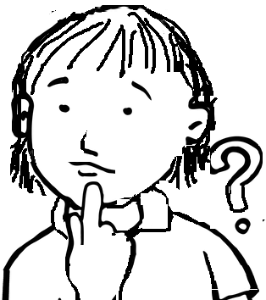
How has it changed?

How can you make hard plasticine go soft?

