Measuring magnetic pull |  | Science  Year 4

Overview  Students identified magnetism as a noncontact force. They noticed that different magnets appeared to have different strengths. They also noticed that distance between magnets affected the size of the magnetic force.  Objectives  To develop learning opportunities for deepening understanding about different forces and for identifying contact and non contact forces.  Activity  Tape a magnet (A) to a desk and place another magnet (B) in the balance basket, so they are “attached”. Gently place weights in the other basket to determine the number required in order to separate them. Check that the force of placing in the weight has not affected the pull.  Compare and record the strength of different magnets. How could you find out whether 2 magnets are stronger than one? What other things do you notice? What is the effect of placing a spacers between magnet A and B?  Record data and observations.  Assessment  Science Understanding - Draws a diagram of the experiment, showing the contact and noncontact forces with directional arrows. Ability to back up conclusions drawn with the data collected.  Science Inquiry – Ability to conduct, observe, record and reflect  Science as a Human Endeavour – Ability to describe patterns and relationships eg correlates weight on the pull with the strength of the magnet and uses this to predict – eg HM weights would be needed if these 3 magnets were joined together?  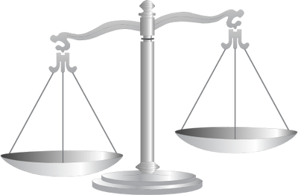 |  | Materials  6 Magnets  Balance scales  Weights  Tape  6 spacers  Australian Curriculum Year 4  Science Understanding  Forces can be exerted by one object on another through direct contact or from a distance  Science as a Human Endeavour  Science involves making predictions and describing patterns and relationships  Science Inquiry Skills  Suggest ways to plan and conduct investigations to find answers to questions  Use formal measurements  Use tables and simple column graphs  Suggest possible reasons for findings  Reflect on the investigation, - was it fair?

