Observation sheet
The diagram below shows the appearance of both trays before they were rained on.
SAND NO GRASS SAND WITH GRASS
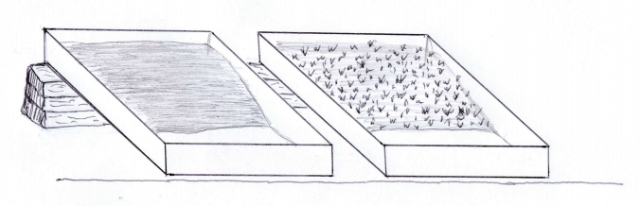

What effect does vegetation have on how soil moves when rain falls on it?
Complete the table below to describe the appearance of each tray after the rain came.
TRAY | OBSERVATIONS
Tray of sand without grass
Tray of sand covered with grass

In this activity sand is used instead of soil. The water falling from the cup represents rain and the sand in the trays represents soil.
Soil erosion occurs when moving water washes away soil.
Complete the following sentences using words from the box below.
Grass protects soil from ___________ in two ways.
- The grass slows the ________ of the raindrops falling ________ the sky. This reduces the ______ of the raindrops hitting the _______.
- The roots of the ________ help to hold the _________ of soil together, preventing the soil from being _________ away.
grass washed from speed erosion soil force
clumps

