Investigating patterns of inheritance

Planning ahead and equipment list

Planning ahead
- Order seeds (Southern Biological is the supplier in Australia http://www.southernbiological.com/)
- Photocopy worksheets, one copy of each for each student.
- The seeds can take up to a week to geminate. Therefore, there will be at least a week between planting the seeds and obtaining the results.
- Preparing the Human trait wheel. The traits can be written on the wheel before copying or the students can write them on themselves. It is important that all students have the same traits in the same location. See example below.
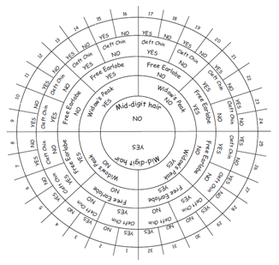

Activity: A tour of basic genetics
Equipment needed per student:
- A tour of basic genetics worksheet
- access to the internet
- access to a computer
This activity could be done individually, in pairs or groups depending on the class and computer access.

Investigation 1: What traits do you have?
Equipment needed per class:
- Investigating patterns of inheritance PowerPoint – Slides 5–7
Equipment needed per student:
- Human traits checklist worksheet
- Human traits wheel worksheet

Investigation 2: Exploring the inheritance of single gene traits
(this investigation should be set up approximately a week before the class)
Equipment needed per class:
- Investigating patterns of inheritance PowerPoint – Slides 2–4 and 8–16
- Investigating patterns of inheritance worksheet
Equipment needed per group:
- 20 x genetic barley seeds (heterozygous for pigment)
- 1 x large petri dish or 2 x small petri dishes (or similar containers)
- enough cotton wool to cover bottom of petri dish/es
- 3 x takeaway food containers or 2 x ice cream containers (or similar)
- potting mix to fill container
- gloves
- face mask

