Forms of energy Planning ahead and equipment list

Introduction
Equipment per class:
- sticky notes
- chart with heading ‘What we think’

Investigation 1: Water drop
Prior planning:
This investigation is best done outside on a flat, hard surface with plenty of space, but one that it won’t matter if it gets wet.
Equipment per group:
- clear plastic straw
- paper cup (recyclable)
- metre ruler
- marker pen
- newspaper or butcher’s paper (minimum of 20–30 sheets per group)
- weights to hold the newspaper flat

Investigation 2: Dismantle a device
Prior planning:
Some weeks prior to starting this investigation, ask your students if they have any old devices at home that are no longer needed such as old mobile phones, old iPods, old TV remote controls, fans, calculators, etc.
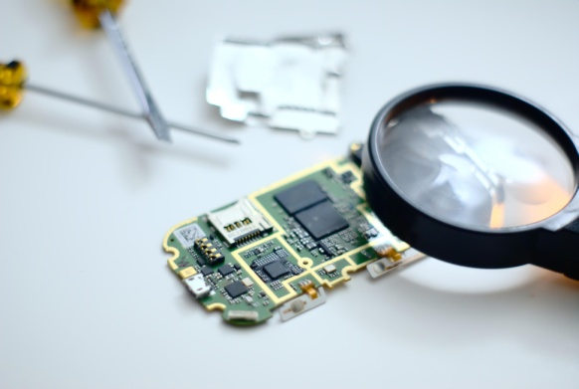Photo by jppi at Morguefile.com
Equipment per group:
- student investigation sheet
- screwdrivers
- magnifying glass
- other tools as required
Shared amongst the class:
- several devices partly dismantled to show their interior components

Investigation 3: Energy efficiency
Prior planning:
Gather at least three different kettles from around the school or from other sources. Each group should investigate three different kettles, so depending how many are available, these may have to be rotated from group to group.
Equipment per group:
- three different electric kettles
- thermometer
- 500 mL measuring cylinder
- stopwatch
- tap water

