The rock cycle Planning ahead and equipment list

Introduction
Equipment needed per student:
- rock sample
- hand lens
- A4 sheet of paper (plus extra sheet for group)
- plastic wobbly eyes and glue (optional)
You could ask students to bring in a rock for this activity, or you could provide the rocks. The rocks will be used for this activity and in Investigation 4: Classifying rocks.
Many students use hand lenses incorrectly. Demonstrate the correct use of the hand lens to students before they observe their rocks.
How to use a hand lens to view rocks
When using a hand lens or magnifying glass, it should be kept close to the eye. The object being observed should be moved toward the lens. Never move the lens toward the object.

Investigation 1: The formation of sedimentary rocks
Equipment needed per class:
- PowerPoint presentation, The rock cycle. Slides 2–11
Equipment needed per group:
- sample of sand and sandstone
- hand lens
- two different coloured wax crayons
- grater
- 15 cm square of aluminium foil
- sheet of paper towel
- bench protector
- safety glasses
- iPhone/iPad/digital camera (optional)
Equipment needed per student:
- Student worksheet 1: Think/Pair/Share
- Student worksheet 2: Formation of sedimentary rocks summary
If you don't have samples of sand and sandstone, you can use the images provided in the rock pictures document.
Sand | Sandstone
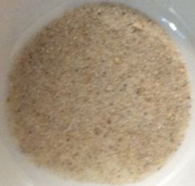 | 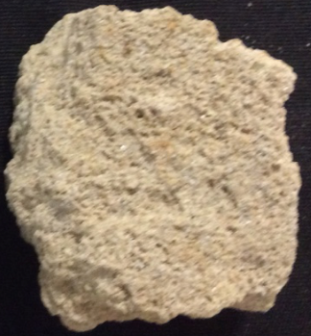

Investigation 2: The formation of metamorphic rocks
Equipment needed per class:
- PowerPoint presentation, The rock cycle. Slides 12–19
- kettle or urn
Equipment needed per group:
- sample of sandstone and quartzite
- hand lens
- ‘sedimentary’ crayons wrapped in foil from Investigation 1
- crucible tongs
- small aluminium tart pan
- 250 mL beaker of hot water
- toothpick
- bench protector
- safety glasses
- iPhone/iPad/digital camera (optional)
Equipment needed per student:
- Student worksheet 1: Think/Pair/Share
- Student worksheet 3: Formation of metamorphic rocks summary

If you don't have samples of sandstone and quartzite, you can use the images provided in the rock pictures document.
Sandstone | Quartzite
 | 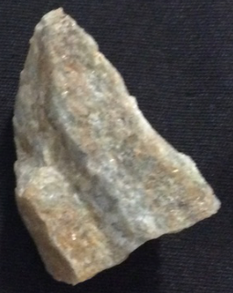

Investigation 3: The formation of igneous rocks
Equipment needed per class:
- PowerPoint presentation, The rock cycle. Slides 20–25
- kettle or urn
Equipment needed per group:
- sample of quartzite and granite
- hand lens
- metamorphic crayons in aluminium foil tray from Investigation 2
- crucible tongs
- 250 mL beaker of hot water
- 250 mL beaker of ice or ice water or warm water
- bench protector
- safety glasses
- iPhone/iPad/digital camera (optional)
Per student:
- Student worksheet 1: Think/Pair/Share
- Student worksheet 4: Formation of igneous rocks summary

If you don't have samples of quartzite and granite, you can use the images provided in the rock pictures document.
Granite | Quartzite
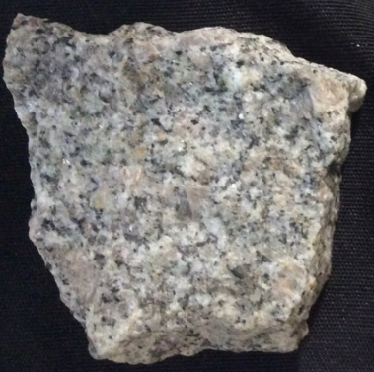
Note: In the cooling phase, students should select, or be allocated, one of these three methods of cooling their rock. The results of the different cooling methods can then be compared.

Investigation 4: Classifying rocks
Equipment needed per class:
- Rock station cards
Equipment needed per group:
- rock samples from introduction activity
- hand lens
- additional rock samples (optional)

You need to ensure each group has at least one sample for each rock type. If students brought in their own rock for the introduction activity, you will need to check that there are samples of each type of rock. Add some extra rocks if required.

Prior to the activity, set up rock stations around the room. Each station should have a label, and an ‘Agree’ and ‘Disagree’ card. If you are going to reuse these cards, you might like to laminate them first.

If you are unable to classify some of the rocks, set them aside. If you have a rock expert in you school, you could ask them, or you could get some students to see if they are able to find out.

Conclusion
Equipment needed per class:
- PowerPoint presentation, The rock cycle. Slides 26–27
Equipment needed per group:
- A simple rock cycle card
- samples of the following: sandstone, granite, quartzite
- additional rock samples (optional)
Equipment needed per student:
- A3 paper or poster paper for rock cycle model

Copy a simple rock cycle card per group. You might like to laminate them if you are going to reuse them.
If you don't have samples of sandstone, granite and quartzite, you can use the images in the rock pictures document.
Make a set of cards per group. These could be laminated and stored in zip-lock bags.
Granite | Sandstone | Quartzite

