Push or pull?
Sort the pictures into groups. Are the objects being pushed or pulled—or both pushed and pulled?

 | 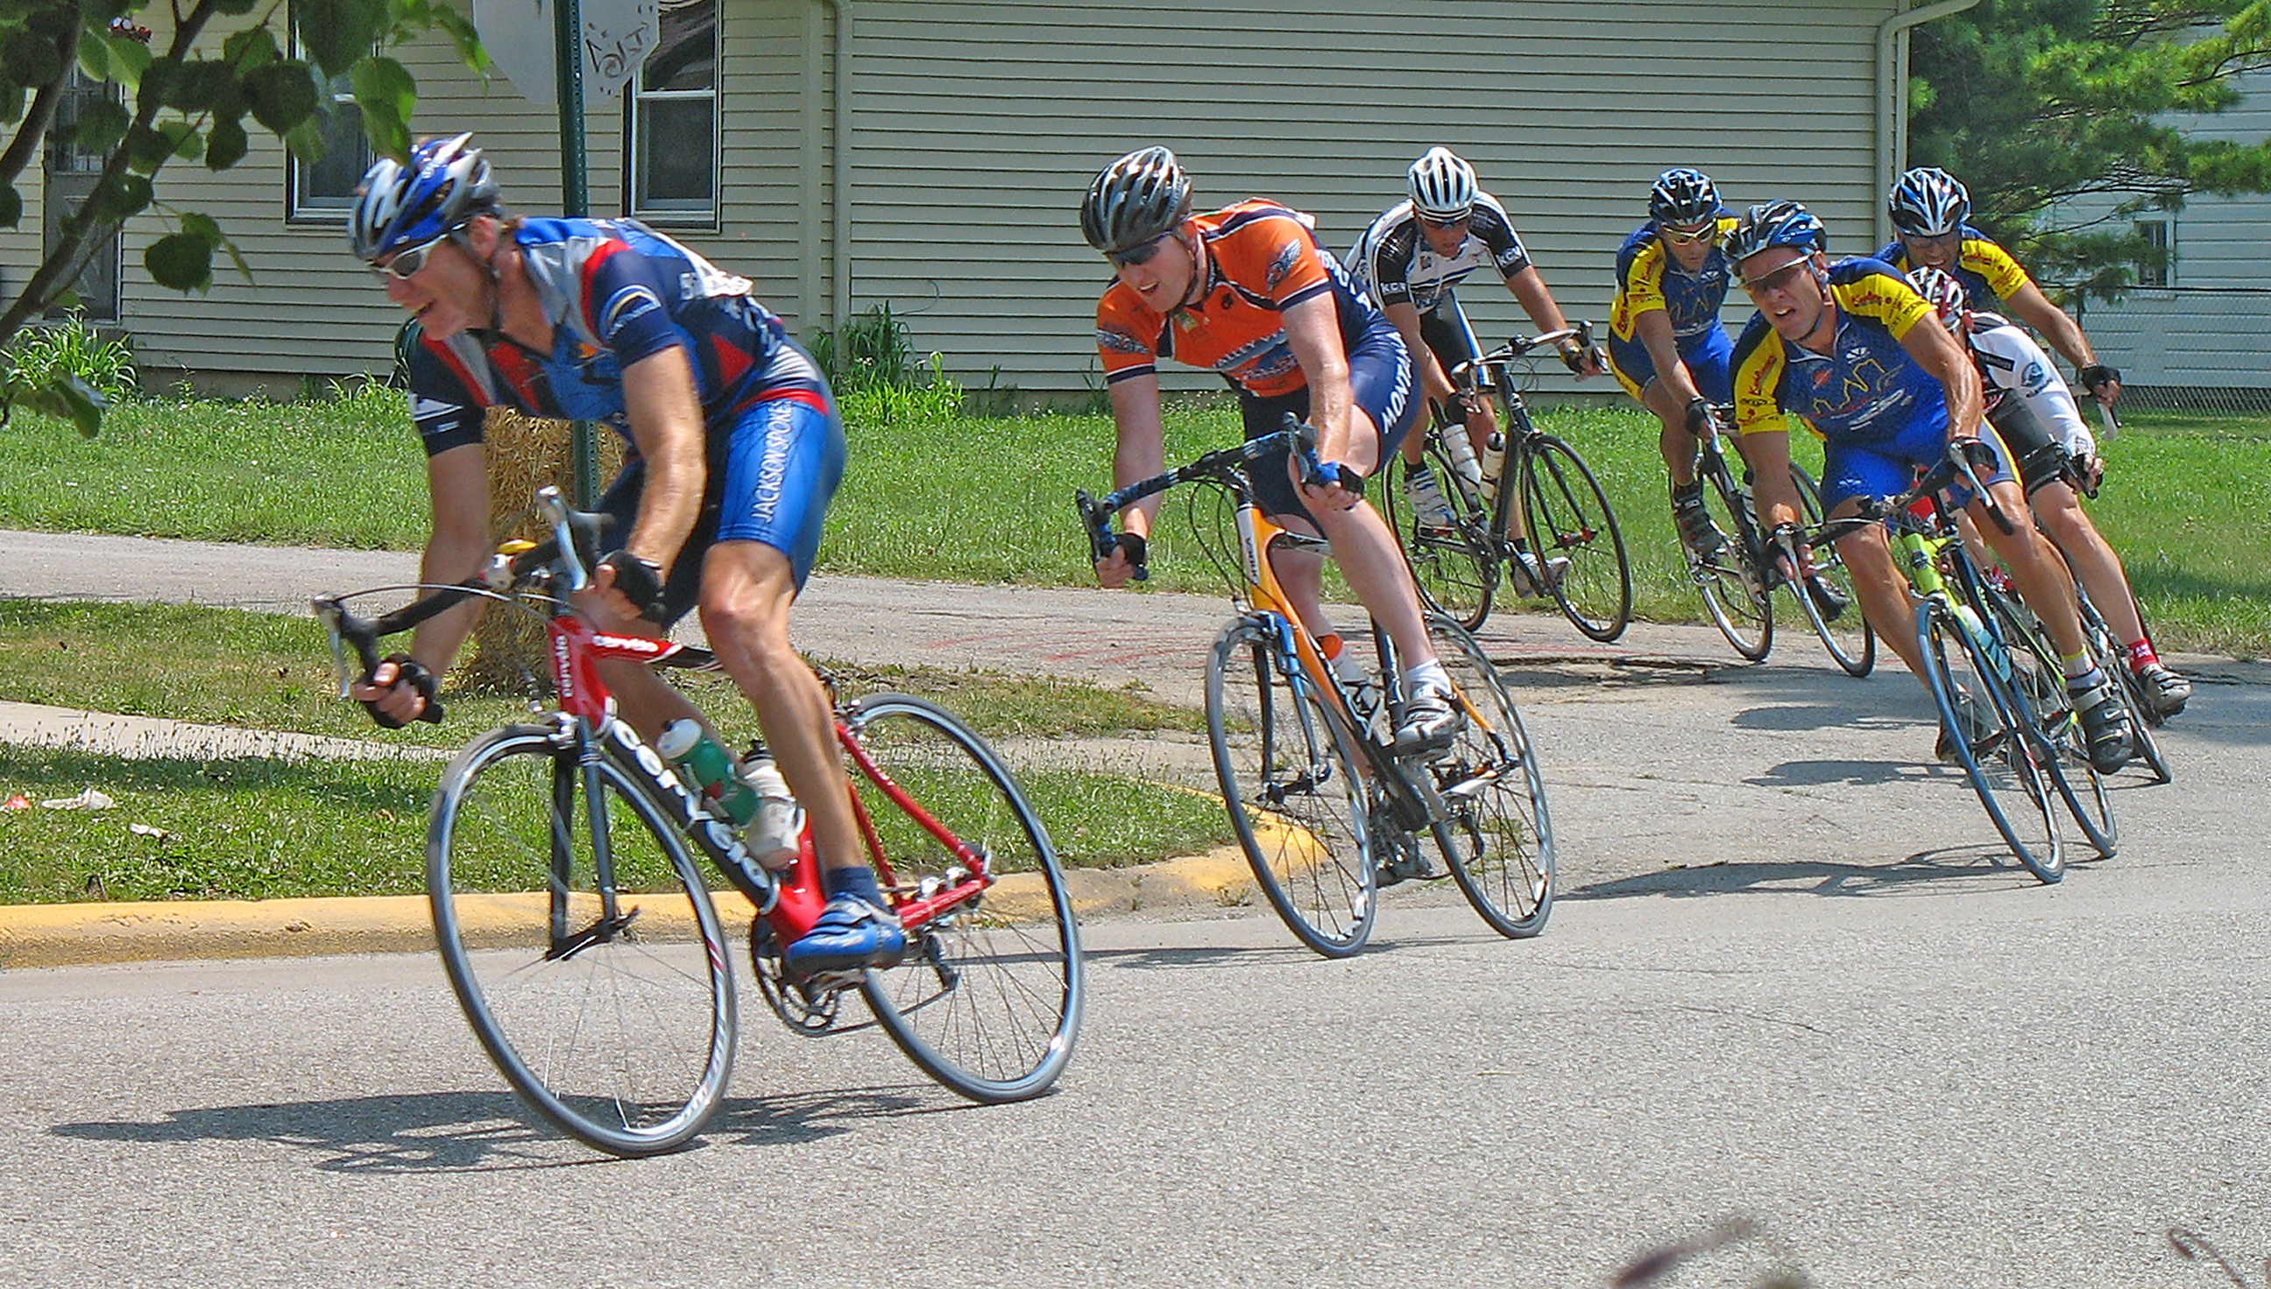
 | 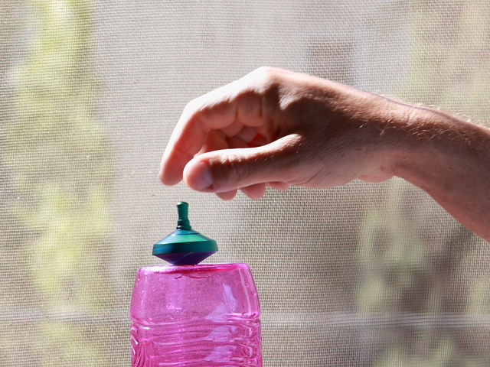 | 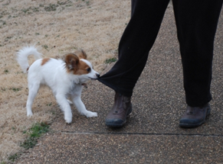
 |  | 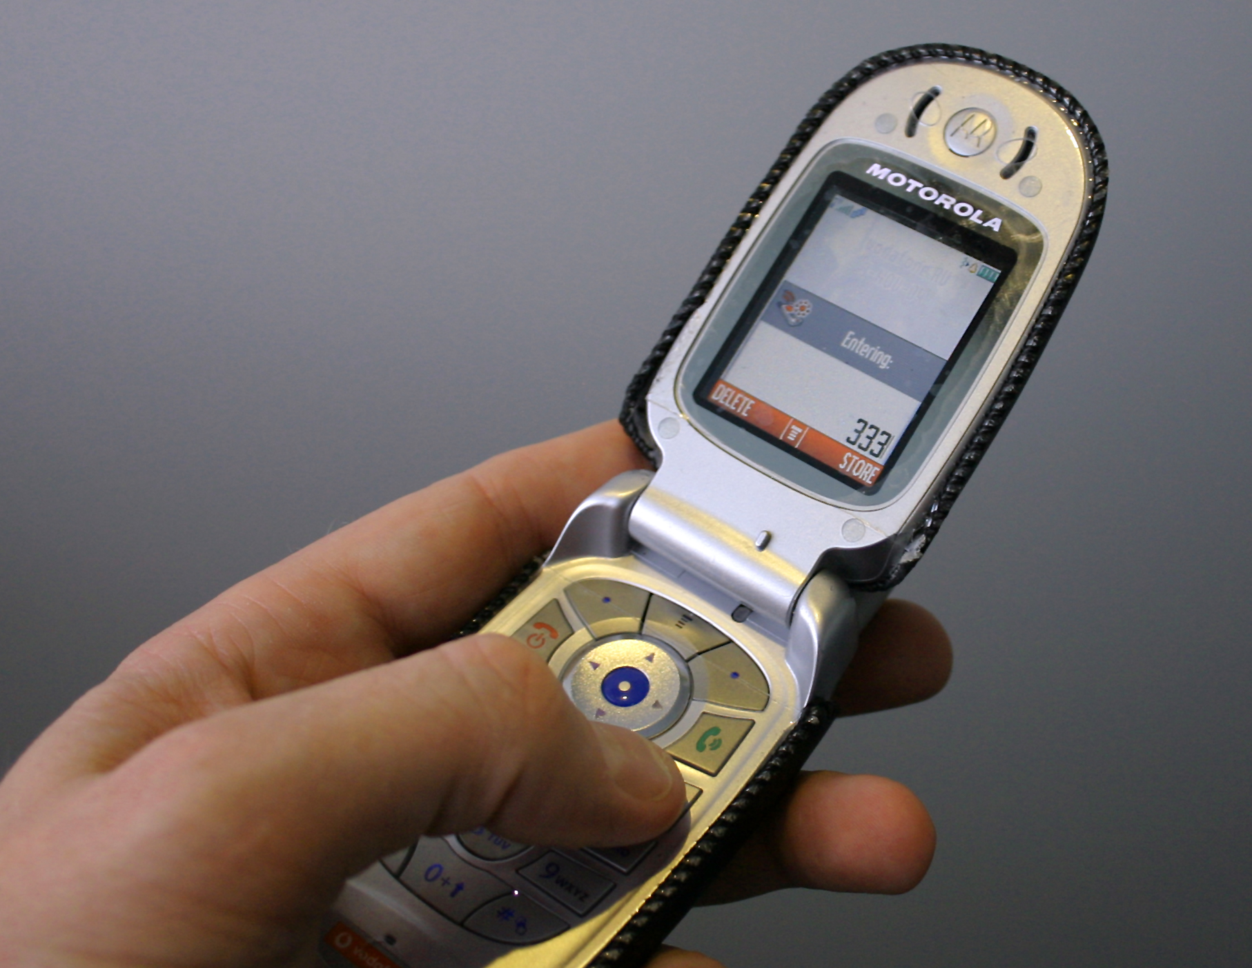
Push

Pull
Push
and pull

