PRACTICAL INVESTIGATION

DETERMINING RESISTANCE

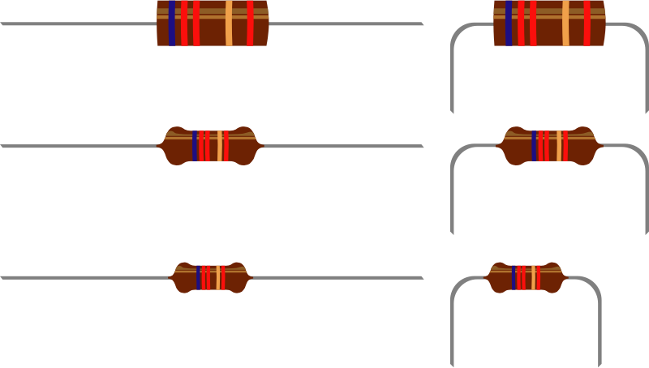

Formulate a practical investigation that involves:

- determining the resistance of an unknown resistor
- comparing its experimental resistance to its nominal value (determined from the coloured bands)

Plan your investigation carefully, including:

            - prediction

            - observation

            - explanation

            - repetition of results to confirm accuracy

- graphing

- NOTE: This investigation is to be done during classtime. You may work in a small group. However, each person has to submit their own report of the investigation using the normal investigation layout (aim, hypothesis, apparatus, results etc.)

This is YOUR investigation, and you are free to plan it yourself, but some questions you might like to consider might be:

- what will be investigated?
- what will be needed?
- what will be measured?
- what will be compared?
- are any safety precautions necessary?
- how will it be a ‘fair’ test?
- how will the results be recorded?
- how many repetitions will be needed?
- what graphs will be drawn?
- what do the results show?

