**Igneous**

**rocks**

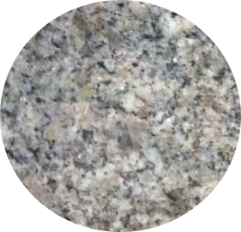



**Agree**



**DisagreeSedimentary rocks**

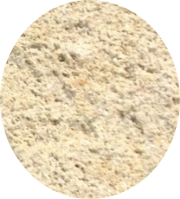



**Agree**



**Disagree**

**Metamorphic rocks**

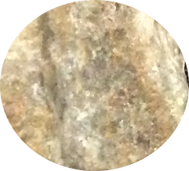

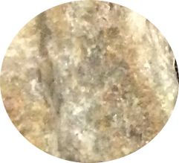

**Agree**



**Disagree**