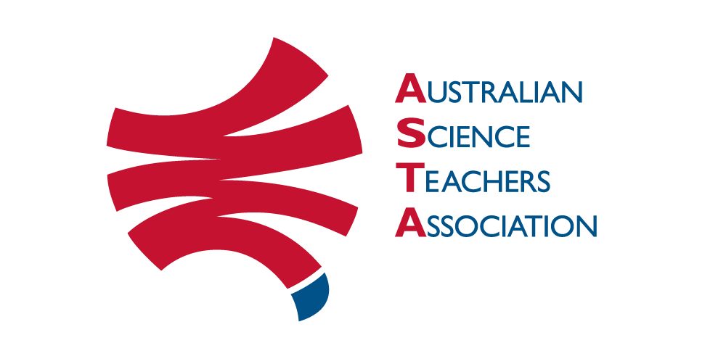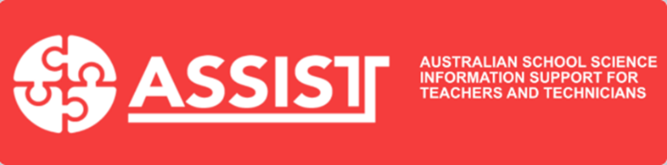

Science ASSIST: Subscription form for Australian schools
Science ASSIST is Australia’s national online advisory service for school science educators and technicians. Science ASSIST is maintained by the Australian Science Teachers Association (ASTA) in consultation with Science Education Technicians Australia (SETA). For more details see https://assist.asta.edu.au/about-assist.
ASTA charges an annual subscription of $150 (ex. GST) per Australian school payable in January each year.
ASTA will contact your school via the accounts contact listed below to provide you with an invoice. Your school’s website contact will be sent a username and a one-time login to set a password, which can then be provided to other relevant staff members, to enable a subscriber level access to the Science ASSIST website.
If you are an individual, or not an Australian school, and you are interested in subscribing to Science ASSIST do not fill in this form. Instead, please or contact us at labsupport@asta.edu.au.
By subscribing to Science ASSIST you are able to access new and updated resources, ask questions via the online Q&A advisory service and are helping us continue this service. We can let you know when new and updated resources have been added to the website via our free monthly e-newsletter. If you are not already on the mailing list, but would like to be, follow the directions at http://asta.edu.au/programs/assist/subscribe_to_science_assist_enews.
Please note that as long as the site remains available content added to the site prior to 1 July 2020 will remain publicly accessible.
* Required
School name*
School address*
Suburb/Town*
Postcode*
State or Territory* | Please enter your Australian jurisdiction. If this doesn't apply, choose 'Other'.  Australian Capital Territory New South Wales Northern Territory Queensland  South Australia Tasmania Victoria Western Australia Other
Region category | Please choose your region category from the list shown on this Australian Bureau of Statistics web page https://www.abs.gov.au/websitedbs/D3310114.nsf/home/remoteness+structure  Major city of Australia Inner Regional Australia Outer Regional Australia  Remote Australia Not sure
Institution sector * | Please choose the closest appropriate category from the available list.  Government School Catholic School Independent School Other Institution
Institution year levels * | Please indicate their age range (e.g., K–6, K–12, 7–10, etc.)
Staff usage | How many staff in your school are likely to use the Science ASSIST service?  It’s just me 2-5 6-10 >10
School accounts contact details | Please enter the name, phone number and email address of the person in your institution responsible for financial accounts.  Name:  Phone:  Email address:
Science ASSIST Website contact  Contact's telephone number | Please enter the name, email address, phone number and role of the person in your institution best suited to act as a contact for website access. This email address will be the one used to set up subscriptions and for responses to any questions asked. Please include the area code for landlines.  Name:  Email address:  Phone:  Role:
Terms of Use and Privacy Policy
The Terms of Use for the Science ASSIST website are available at https://assist.asta.edu.au/science-assist-website-terms-use
The Privacy Policy for the Science ASSIST website is available at https://assist.asta.edu.au/science-assist-privacy-policy
Please email this completed form to Teresa Gigengack at labsupport@asta.edu.au

