**Smoke Detectors - Answers**

From your research on smoke detectors, answer the following:

1. Name the radioactive substance used in ionization smoke detectors. Americium-241 (1 mark)

2. Why is this substance used? Half life of 432 years meaning it won’t run out, alpha particles with high ionization which means enough gas molecules in the air will be ionized for the electric current to keep flowing, low penetration of alphas makes it safe as they will be stopped by the plastic casing. (3 marks)

3. Write a balanced radioactive decay equation for this substance.

🡪 (3 marks)

4. Mark on this floor plan, where the smoke detector(s) should be placed and explain why.

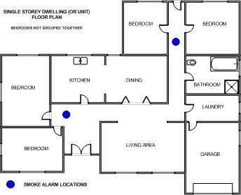

The ceiling is the best place as smoke is lighter than air and rises. Outside bedrooms is best but not in the kitchen to avoid false alarms. (2 + 2 = 4 marks)

5. Smoke detectors should be positioned horizontally on the ceiling. What if the ceiling isn’t horizontal, like that shown in this photo. Where should it be placed and why? 500 – 1500 mm from the highest point, the apex is a “dead-spot” where hot air can get trapped and the smoke may not reach the detector if it is positioned here. (2 marks)

6. In the ionization chamber of a smoke detector, there are two plates. How far apart are they? About 1 centimetre (1 mark)

7. What type of battery is needed and why is it needed? A 9V battery, to charge the two plates, one positive and the other negative. (2 marks)

8. When the smoke detector is off (i.e. not sounding), is a current flowing between the plates or is no current flowing? Explain your answer. A current flows. The alpha particles ionize the air molecules and the resulting positive ions and electrons flow to the negative and positive plates respectively and create a current. (2 marks)

9. This photo shows the inside of a typical smoke detector with the cover removed. Label five main components. (5 marks)

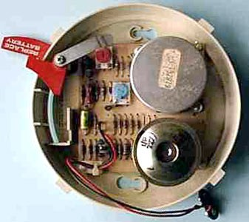

Battery connector

buzzer

circuitry

Battery compartment

Ionization chamber

10. Find a photo that that you could use to show **how** smoke enters the ionization chamber. Label your photo.

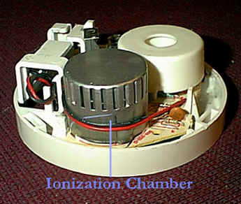 (2 + 1 = 3 marks)

This photo shows the slots or holes in the sides of the ionization chamber that allow the smoke to enter and disrupt the current flow between the plates, thus setting off the alarm.

11. What happens inside the ionization chamber when smoke enters? When smoke enters, it disrupts (or neutralises) the oxygen and nitrogen ions. This causes a decrease in the current because the ions are not attracted to the negative plate anymore, setting off the buzzer. (2 marks)

12. Find and write a quote or catch phrase that is used for promoting smoke detector maintenance. Who promotes the phrase you have chosen? What is the logic behind it? The CFA and MFB say “change your clock, change your smoke detector batteries.” This reminds us to change the smoke detector batteries every six months when the clocks are changed for daylight saving. (3 marks)

13. Australian smoke detectors you buy must carry the Australian Standards mark, or SSL label, and some have both. Find a photo of an Australian made smoke detector and identify these two marks. Why are these important?

 may not have both marks (2 + 1 = 3 marks)

Australian Standards label

These markings indicate SSL – that it has been tested in the scientific services laboratory and AS – it meets the requirements of the standard.

14. Find a success story about smoke detectors in Australia, or better in Melbourne and even better, a recent one. Give the details in your own words. Answers will vary (3 marks)

15. Bibliography of websites used (3 marks)