Smoke Detectors
Instructions: From your research on smoke detectors, answer the following questions in a written report. Read Q15 before you begin.

1. Name the radioactive substance used in ionization smoke detectors. (1 mark)
2. Why is this substance used? Give three reasons. (3 marks)
3. Write a balanced radioactive decay equation for this substance. (3 marks)
4. Mark on this floor plan, where the smoke detector(s) should be placed and explain why. (4 marks)
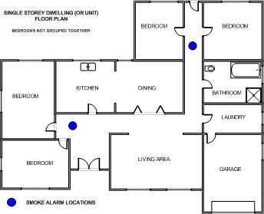

5. Smoke detectors should be positioned horizontally on the ceiling. What if the ceiling isn’t horizontal, like in this photo. Where should it be placed and why? (hint: this is a “cathedral” ceiling). (2 marks)
6. In the ionization chamber of a smoke detector, there are two plates. How far apart are they? Examine the smoke detector in class and measure the distance. ( 1 mark)
7. What voltage battery is needed for a smoke detector and what is the battery’s job? (2 marks)
8. When the smoke detector is off (i.e. not sounding), is a current flowing between the plates or is no current flowing? Explain your answer. (2 marks)
9. This photo shows the inside of a typical smoke detector with the cover removed. Label five main components. (5 marks)
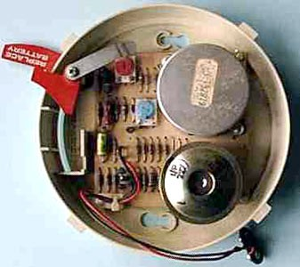

10. Find a photo that that you could use to show how smoke enters the ionization chamber. Label your photo. (3 marks)
11. What happens inside the ionization chamber when smoke enters? (2 marks)
12. Find and write a quote or catch phrase that is used for promoting changing the battery in a smoke detector. Who promotes the phrase you have chosen? What is the logic behind it? (3 marks)
13. Australian smoke detectors you buy must carry the Australian Standards marking and some have a “tick” marking as well. Find a photo of an Australian made smoke detector and circle any of these markings. Why are these marks important? (3 marks)
14. Find a success story about smoke detectors saving lives in Australia and even better, a recent one. Give the details of the story in your own words. (3 marks)
15. Include a list of the websites you used. (3 marks)

