Average distance between the planets
From | To | KM | Time to reach
Mercury | Venus | 50,290,000
Mercury | Earth | 91,691,000
Mercury | Mars | 170,030,000
Mercury | Jupiter | 720,420,000
Mercury | Saturn | 1,366,690,000
Mercury | Uranus | 2,815,640,000
Mercury | Neptune | 4,443,090,000
Venus | Earth | 41,400,000
Venus | Mars | 119,740,000
Venus | Jupiter | 670,130,000
Venus | Saturn | 1,316,400,000
Venus | Uranus | 2,765,350,000
Venus | Neptune | 4,392,800,000
Earth | Mars | 78,340,000
Earth | Jupiter | 628,730,000
Earth | Saturn | 1,275,000,000
Earth | Uranus | 2,723,950,000
Earth | Neptune | 4,351,400,000
Mars | Jupiter | 550,390,000
Mars | Saturn | 1,196,660,000
Mars | Uranus | 2,645,610,000
Mars | Neptune | 4,273,060,000
Jupiter | Saturn | 646,270,000
Jupiter | Uranus | 2,095,220,000
Jupiter | Neptune | 3,722,670,000
Saturn | Uranus | 1,448,950,000
Saturn | Neptune | 3,076,400,000
Uranus | Neptune | 1,627,450,000
How far away are the planets?
Work with a partner, and use the data in the table to help you answer these questions.
1. Which planet is the closest to Earth?

2. Approximately how far is it from Earth?

3. Write the distance in words. (See the tip below.)

4. Which planet is furthest from Earth?

5. Approximately how far is it from Earth?

6. Write the distance in words.

7. Based on this information, which planet would you consider to be the most suitable for settlement? Why?

Use the data to create your own questions to ask another group. Write the questions and your answers on the back.

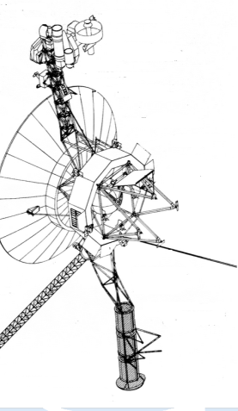
TIP
Can you work out:
- How far it would travel in a day?
- How far it would travel in a year?
At that average speed, how long would a space probe launched from Earth take to reach the orbit of the different planets? Write the estimated time in the blanks of the last column of the chart. Use a calculator to help you.

year

day
Voyager 1 is a space probe launched by NASA on September 5, 1977, to study the outer Solar System. It travels at a velocity of 61,000 km/h.
Reading large numbers
A million 1,000,000
A billion 1,000,000,000 (one thousand million)
A trillion 1,000,000,000,000 (one million million)

