Space tourism Teaching and learning plan

Learning intentions
Students will be able to:
- use a scale model to demonstrate the distances between the planets in our solar system;
- understand that a model is a representation of some aspect of the real world, which can be useful in developing our understanding of that aspect;
- understand the vast distances within the solar system;
- discuss how scientific discoveries in space have affected people’s lives;
- draw conclusions about the probability of space travel and space tourism.

Suggested time for this CLE
The time need to complete the Space tourism CLE will depend on the depth of the prior knowledge of students, the time to perform the five investigations—'Pocket solar system', 'What is space tourism?', 'Astronaut requirements', 'Life in orbit according to Commander Chris Hadfield' and 'Space medicine'—and follow up with any further extension activities. Allow 3–6 hours.
NOTE: This CLE is aimed at enhancing a unit already being taught on the solar system.

Planning ahead and equipment list

Safety considerations
When you and your class are completing your Risk Assessment, consider the following safety points and add any other relevant ones to the list.
- That there is enough space to conduct/measure the tape for the pocket solar system.

______________________

Introduction
This CLE focuses on the human endeavour that has occurred as a result of space exploration and links to the Year 5 Australian Curriculum: Science. This CLE is aimed at providing activities to enhance a unit on the solar system. Students will conduct research into space exploration and how humans survive in space, as well as make conclusions about whether humans living in space is viable and whether mass space tourism is possible.

What to do
- Review the position of the planets and other bodies in the solar system i.e., the sun and the asteroid belt.
- Discuss how there are large distances between these planets and that it can be difficult to understand how vast these distances are.
- Inform students that they will be constructing a model of the solar system that they can use to help them understand these vast distances.

Core

Investigation 1: Pocket solar system
Students will conduct an activity to demonstrate the vast distances between the planets. This activity is adapted from the sheet, ‘Pocket Solar System’, from the Astronomical Society of the Pacific website https://astrosociety.org/wp-content/uploads/2012/09/PocketSolarSystem.pdf

Equipment needed
Per student:
- 1 strip of thermal paper cut to size (see Planning ahead and equipment list for instructions)
- pen or pencil
- printout of the table from the ‘Pocket Solar System’ resource (optional, as this could be displayed on an IWB instead)

What to do
Instruct students to follow you as you demonstrate the construction of the pocket solar system. Walk students through each step below.
- Firstly, label one end of the thermal paper ‘Sun’, and the other end, ‘Pluto/Kuiper Belt’.
- Next, fold the paper in half, crease it, open it up and lay it flat.
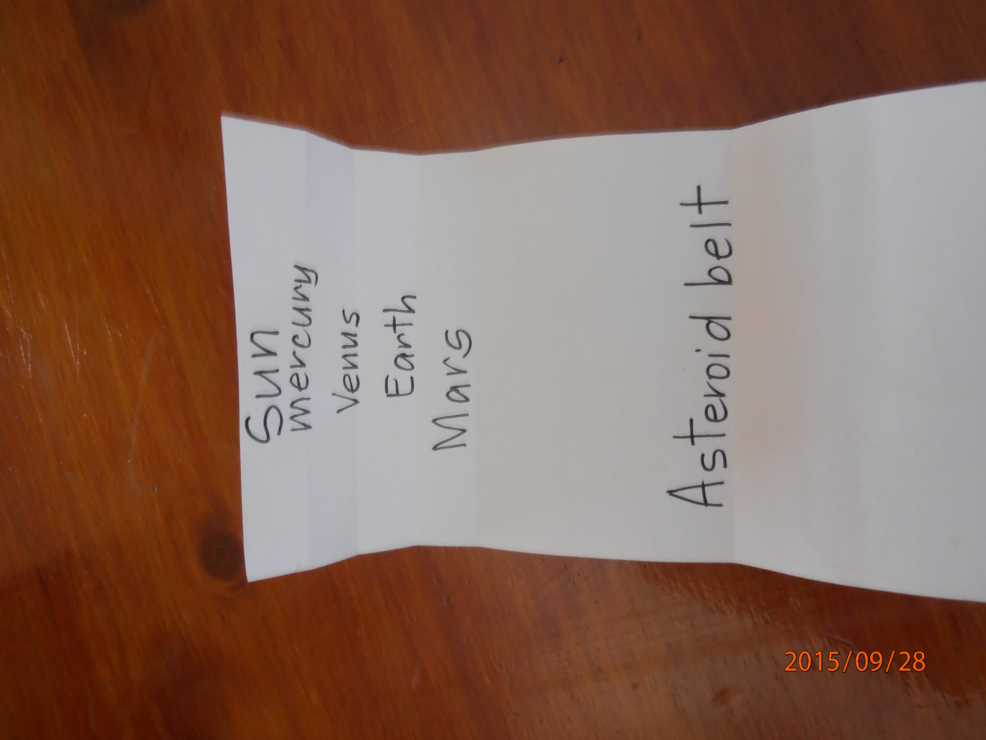
- Label the crease in the middle as ‘Uranus’.
- Now fold the tape back in half, then in half again. Unfold and lay it flat as before.
- Label the quarter crease as ‘Saturn’ (closest to the sun) and three quarter crease as ‘Neptune (closest to Pluto).
- Now fold the ‘Sun’ end up to ‘Saturn’ and crease it. Unfold it and lay flat again.
- Label this crease ‘Jupiter’ (between the Sun and Saturn).
- Next fold the ‘Sun’ end out to meet ‘Jupiter’ and crease the paper.
- Open and label this crease ‘Asteroid belt’.
- Now fold the ‘Sun’ end to the ‘Asteroid Belt’ mark and crease it.
- Unfold the paper and label this crease ‘Mars’ (between the ‘Sun’ and ‘Asteroid Belt’).
- Lastly, fold the ‘Sun’ end up to meet the line for ‘Mars’. Leave it folded and fold that section in half again.
- Unfold the paper and there will be three creases.
- Mark ‘Earth’ on the crease nearest ‘Mars’, ‘Venus’ on the middle crease and ‘Mercury’ on the crease closest to the sun.
- The pocket solar system is now complete.

Expected results and explanations
Students should now have a completed solar system that can be rolled and placed in their ‘pocket’
Images courtesy of Shelley Murphy.

Class discussion
- Conduct a discussion with students about the model and how it represents the vast distances in the solar system.
- Examine the model and discuss how the planet ‘Uranus’ is demonstrated to be in the middle of the solar system.
- From our understanding of the solar system, discuss how Uranus would not normally be considered to be the middle planet, but due to the vast distances involved, that this is actually the case.
- Further examine the model and discuss how three quarters of the solar system is taken up with the four gas giants and Pluto, and that the rest of the solar system, including the asteroid belt, takes up the other quarter.
- Discuss how empty this makes the solar system and how far away from each other the planets actually are.
- Display on an IWB (or, if preferred, provide each student with a copy of) the table in the ‘Pocket Solar System’ resource (from the Astronomical Society of the Pacific website) that demonstrates the actual distances in kilometres and astronomical units (AU) between the planets.
- Discuss the vast distances from the sun and between each planet that are described. Explain that the measurement unit AU assists in understanding the distances between the planets, however, due to the vast distances in space, the measurement light years is used to describe distances beyond the solar system.
- Discuss whether these distances between planets would make it easy or harder for space travel and how probable it could be to travel the solar system.
- Discuss how, with the advances in technology, there is more interest in people travelling the solar system and becoming space ‘tourists’.
- Inform students that they will be conducting research to determine how probable/possible space tourism could be.

Investigation 2: What is space tourism?
Students will research information about space tourism to gain an understanding of what the phrase means.
Note: This activity could be conducted as a whole class or, time permitting, by using small ‘expert’ groups in a jigsaw format. Students could be given the key concepts to research from below and return to discuss their findings with the class.

Equipment needed
- Access to computers and the internet

What to do
- Instruct students to read the Wikipedia web page ‘Space tourism’ https://en.wikipedia.org/wiki/Space_tourism to gain information about the question ‘What is space tourism?’ and the companies that are currently offering space travel to ‘tourists’.
- Examine the list of people that have travelled to space as tourists so far and discuss their qualifications and motivations.
- Instruct students to visit the website Virgin Galactic http://www.virgingalactic.com/ and read the information/watch the videos about how Richard Branson’s company is aiming to get people to space.
- Read the webpage ‘Space tourism: How much should you save for a space trip?’ on the Finances online website http://financesonline.com/space-tourism-how-much-should-you-save-for-a-space-trip/
- Discuss the costs that would/could be involved for this kind of space travel. (Tickets on Virgin Galactic are currently set at $250,000 per person.)
- Discuss the claim on the Virgin Galactic website that: “Only 551 people have been to space. Virgin Galactic is opening space to the rest of us”.
- Clarify how having scientific knowledge of space and space exploration has influenced technological developments, and how collaboration between countries and agencies across the globe have contributed to this scientific knowledge.
- Have students collate their findings for later reference.

Investigation 3: Astronaut requirements
Students will discuss the requirements it takes to become an astronaut.

Equipment needed
- Access to computers and the internet

What to do
- Instruct students to read the webpage ‘Astronaut requirements’ on the NASA website http://www.nasa.gov/audience/forstudents/postsecondary/features/F_Astronaut_Requirements.html.
- Discuss the academic requirements necessary for people to become an astronaut.
- Instruct students to read about astronaut training on the European Space Agency Kids website https://www.esa.int/esaKIDSen/SEM3RIWJD1E_LifeinSpace_0.html and to list some of the training required to become an astronaut.
- Discuss with the students the risks that would be involved for astronauts including safety and sickness.
- Clarify/confirm how dangerous space travel is, even for highly trained, professional astronauts.
- Discuss with the students how Virgin Galactic has 600 ‘astronauts’ ready to fly into space and whether (or not) these people have sufficient training or qualifications.
- Discuss with the students the safety implications of having under-qualified people travelling to space.
- Instruct students to collate the information for later reference.

Investigation 4: Life in orbit according to Commander Chris Hadfield
Students will discuss the concepts of what is it like to live and work in space.
Students will watch videos starring Canada’s Commander Chris Hadfield that were recorded shortly after he returned from the International Space Station (ISS) following his 10-month stint in space where he observed the effects of gravity on daily activities.
Note: This activity could be conducted as a whole class or, time permitting, by using small ‘expert’ groups in a jigsaw format. Students could be given the key concepts to research from below and return to discuss their findings with the class.

Equipment needed
- Access to computer and the internet

What to do
- Have students make suggestions about how astronauts might conduct everyday activities in space, such as sleeping, eating, washing and cooking.
- Instruct students to watch videos on the Canadian Space Agency YouTube channel https://www.youtube.com/results?search_query=canadian+space+agency+chris+hadfield related to these tasks and record the information.
- Come together as a class and share the information collected.
- Discuss with students how easy or difficult these tasks are to complete.
- Discuss with students the viability of large numbers of people having to live and work in these conditions in space, if space tourism or mass space travel came to be.
- Discuss with students how scientific knowledge of the effects of gravity, and the research conducted on the ISS, has contributed to technological advances that are used in space and everyday life.
- Instruct students to collate the information for later reference.

Investigation 5: Space medicine
Students will discuss the effects that space has on the human body.

Equipment needed
- Access to computer and the internet

What to do
- Instruct students to read the overview, ‘Effects of space on the body’, Canadian Space Agency website http://www.asc-csa.gc.ca/eng/sciences/osm/concerns.asp.
- Divide students into groups to research different topics:
- Bones http://www.asc-csa.gc.ca/eng/sciences/osm/bones.asp
- Decompression sickness http://www.asc-csa.gc.ca/eng/sciences/osm/decomp.asp
- Muscle http://www.asc-csa.gc.ca/eng/sciences/osm/muscles.asp
- Radiation http://www.asc-csa.gc.ca/eng/sciences/osm/radiation.asp
- Ask students to share the information they have gathered to gain an overall understanding of the effects of space travel on the human body.
- Discuss with students the implications of these effects for astronauts who currently travel to space.
- Discuss with students how these effects make space tourism more or less viable for ordinary citizens.
- Discuss with students how these effects might be resolved to make space tourism more viable for ordinary citizens.
- Discuss with students how research by a range of global space agencies has contributed to our understanding of how the human body works, which has then been applied to medical knowledge for people on Earth.

Conclusion
Students will debate whether space tourism is viable.

Equipment needed
- Information from student investigations

What to do
- Explain to the students that they will be answering the question: ‘Is space tourism viable?’
- Ask students to read through their collated information and decide whether they agree or disagree with the question.
- Conduct a discussion (or debate) about whether space tourism is viable.

Additional websites about space travel and tourism
- ‘Space Tourism: The Latest News, Features and Photos’, Space.com website, http://www.space.com/topics/space-tourism/. Read articles about the latest in commercial space travel.
- ‘International Space Station’, National Aeronautics and Space Administration website, http://www.nasa.gov/mission_pages/station/main/index.html. Investigate and read about the ISS.
- ‘NASA Spinoff’, National Aeronautics and Space Administration website, https://spinoff.nasa.gov/. Investigate technological advances designed for space, being used to benefit people on Earth.

Assessment opportunities
Investigation 1 provides an opportunity to assess student understanding of the concepts related to the Science Understanding that the Earth is part of a system of planets orbiting around a star (the Sun) (ACSSU078)
Investigations 2–5 provide opportunities for students to demonstrate their understanding of the concepts related to Science as a Human Endeavour that address the nature and development of, and the use and influence of science (ACSHE082) (ACSHE083).
In addition, the level of student achievement of the science inquiry skills of communicating (ACSIS093) could be assessed.

