Feeding relationships Teaching and learning plan

Learning intentions
Students will be able to:
- recall that the Sun is the source of all energy in a community;
- describe the role of producers, consumers and decomposers in a community;
- identify animals as being herbivores, carnivores or omnivores from their usual diets;
- draw a simple food chain to show feeding relationships between animals and plants;
- construct and interpret food webs to demonstrate relationships in a community;
- describe how living things can cause changes to their environment and impact other living things;
- collate and summarise data from different sources;
- communicate their ideas using scientific language and appropriate representations.

Suggested timeframe
The time needed to complete the Feeding relationships CLE will depend on the depth of the prior knowledge of students, the time to perform the three investigations—'Investigating feeding relationships 1', 'Investigating feeding relationships 2' and 'Investigating the effect of introduced species'—and follow up with any further extension activities. Allow 4–8 hours.

Planning ahead and equipment list

Safety considerations
When you and your class are completing your Risk Assessment, consider the following safety points and add any other relevant ones to the list:
- No safety considerations are required

______________________

Introduction
This CLE focuses on feeding relationships in a community and links to Year 7 Australian Curriculum: Science.

Equipment needed
Per group:
- Card Set 1—organisms
- Card Set 2—group card labels
- Information sheet 'Feeding relationships in a forest community' (optional)

What to do
The purpose of this activity is find out what students already know about feeding relationships.

- Students work in groups to sort the organisms in Card Set 1 into three groups: producers, consumers and decomposers. Card Set 2 contains the headings for this card sorting activity.
- Discuss grouping with the class. The teacher could use a gallery walk and get students to look at how each group has grouped the organisms, and make suggestions for changes.
- Students work in groups to come up with a definition for ‘producers’, ‘consumers’ and ‘decomposers’.
- Share answers to come up with agreed definitions.
- Each student should record the agreed class definitions.
Optional: Instruct students to sort the consumers further, into herbivores, carnivores and omnivores. The information sheet 'Feeding relationships in a forest community' will help with this.

Expected results and explanations
Producers | Consumers |  | Decomposers
Gum tree  Gum tree nuts (seeds)  Gum tree flowers (nectar)  Shrub  Native grasses | Moth  Ant  Beetle  Grub (insect larvae)  Parrot  Kangaroo  Pygmy possum | Bandicoot  Honeyeater  Frog  Gecko  Quoll  Snake  Eagle | Bacteria  Earthworm  Fungus

Definitions
Producer—an organism that can make its own food.
Consumer—an organism that relies on other organisms for food.
Decomposer—an organism that breaks down dead, decaying organisms.
Herbivore—an organism that eats producers (plants).
Carnivores—an organism that eats consumers (animals).
Omnivores—an organism that eats producers (plants) and consumers (animals).

Optional activity
Producers | Consumers |  |  | Decomposers
 | Herbivores | Omnivores | Carnivores
Gum tree  Gum tree nut (seeds)  Gum tree flower (nectar)  Shrub  Native grass | Moth  Ant  Beetle  Grub (insect larvae)  Parrot  Kangaroo  Pygmy possum | Bandicoot  Honeyeater | Frog  Gecko  Quoll  Snake  Eagle | Bacteria  Earthworm  Fungus

Core

Investigation 1: Investigating feeding relationships 1

Equipment needed
Per group:
- Card Set 1—organisms
- Card Set 3—arrows
- Information sheet 'Feeding relationships in a forest community'

What to do
- Ask the students to take out the gum tree, grub, honeyeater and snake from Card Set 1 and use the information in Table 1 of the Feeding relationships in a forest community information sheet to arrange the pictures in feeding order. Discuss this order with the class and record on the board.
- Explain that when these organisms feed they are actually gaining energy and that we use arrows to show the direction the energy is being passed.
- Ask the students to place an arrow between each organism to show the direction of energy flow.
gum tree grub honeyeater snake
- Explain that the producer, the plant, uses energy from the Sun to make food in a process call photosynthesis.
carbon dioxide + water + sunlight oxygen + food
Plants use this food to make energy to grow in a process called respiration. Animals that eat plants also use respiration to convert the food they eat into energy.
food + oxygen carbon dioxide + water + energy
In the example food chain:
- the grub eats the leaves of the gum tree. Energy is passed from the gum tree to the grub.
- The honeyeater eats the grub. Energy is passed from the grub to honeyeater.
- The snake eats the honeyeater. Energy passes from the honeyeater to the snake.
We call the feeding relationships we have just made, a food chain.
- Introduce the terms first-order consumer, second-order consumer, etc. In this food chain, the gum tree is the producer, the grub is a 1st-order consumer, the honeyeater is a 2nd-order consumer and the snake is a 3rd-order consumer.
- Students record the food chain, label the producer, 1st-order, 2nd-order and 3rd-order consumers, and write a definition for a food chain. They should also note that the original source of energy in a food chain is the Sun.
- Each member of the group should make another food chain using the information in Table 2. Ask the students to check that their food chain starts with a plant and that the arrows show the direction the energy is being passed. Once correct, students should record their food chain.

Expected results and explanations
A food chain shows the direction of energy flow from one organism to another in a community.
There are many possible food chains in this community. Refer to the 'Forest community food web' document provided for Investigation 2 to check possible food chains.
Point out to students, using their food chain examples, that the type of consumer the organism is depends on the food chain they are in. For example:
The honeyeater could be a 1st-order or 2nd-order consumer depending on the food chain it is in.
gum tree flower honeyeater
gum tree flower ant honeyeater

Investigation 2: Investigating feeding relationships 2

Equipment needed
Per group:
- Card Set 1—organisms
- Card Set 3—arrows
- Information sheet 'Feeding relationships in a forest community'

What to do
In this investigation, students will use their food chains from Investigation 1 to make a food web.
- If students packed up their food chains from Investigation 1, ask them to construct them again.
- Explain to students that organisms can be part of more than one food chain.
- Ask each student in the group to line up their food chains on the desk, with the producers at the bottom.
- Students use the 'Feeding relationships in a forest community' information sheet and additional arrows to join their food chains together.
e.g. snake

honeyeater gecko

grub ant

gum tree gum tree flowers
- Once correct, students should record their food web. Make sure that the arrows point in the direction the energy is being passed.
- You could use a gallery walk and ask students to look at each group’s food web.

Expected results and explanations
Below is a food web of the forest community in this activity. A larger version of this diagram is available—'Forest community food web'. This food web shows all the possible interacting food chains.
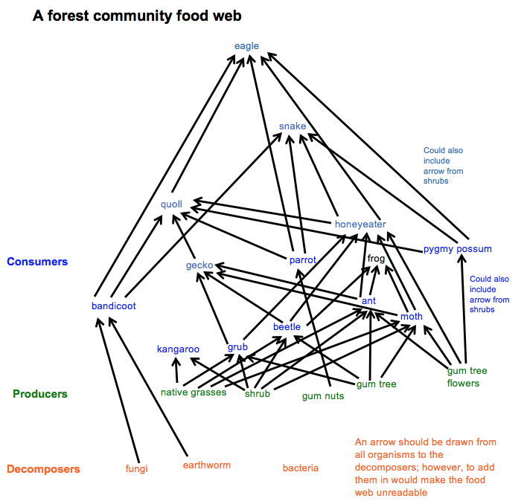

Investigation 3—Investigating the effect of introduced species

Equipment needed
Per group:
- Card Set 1—organisms
- Card Set 3—arrows
- Information sheet 'Feeding relationships in a forest community'
- An introduced species card from Card Set 4—introduced species
- Introduced species fact sheets (See Planning ahead and equipment list)
- Introduced species poster template
- iPad/smart phone/digital camera

What to do
In this investigation, students will investigate the effect of an introduced species on communities and produce a poster summarising their findings.
- Students use Card Sets 1 and 3 to reassemble their food web.
- Allocate an introduced species to each group. Students use the fact sheet to find the answer to the following questions.
- Why was it introduced?
- How is it affecting native plants and animals?
- Record some interesting facts about it.
- How it is being controlled?
- Using the information gathered about their introduced species, ask the students to add their introduced species to their food web, and then describe how it could affect their food web.
- Ask the students to take a photograph of their food web to incorporate into their poster.
- Students use the poster template to prepare a single PowerPoint slide poster about their introduced species.
- Display student posters. Students could do a brief presentation about the effects of their introduced species on their food web.

Expected results and explanations
Summary of the impacts of introduced species
 | Why it was introduced | How it is affecting native plants and animals | How could it affect our food web | Control
Cane toad | control cane beetle | killing native predators  consuming eggs and young nestlings of ground-dwelling birds | e.g. kill animals, therefore less food for higher-order consumers. | collecting eggs and adults
Rabbit | food | destroying native plants  erosion | e.g. kill native grasses, therefore less food for herbivores | biological control (myxomatosis, calicivirus)  poisoning
Fox | recreational hunting | killing small native animals | e.g. kill animals, therefore less food for higher-order consumers. | bounties  baiting
Cat | pets  pest control (mice, rats etc.)  escaped from ships | killing native animals  spreading disease | e.g. kill animals, therefore less food for higher-order consumers. | trapping  to some extent baiting
Goat | milk and meat  hair | erosion  eating grasses, native shrubs and trees | e.g. kill native grasses, therefore less food for herbivores | mustering and shooting from helicopters
Horse | working farm horses | erosion  degrading and fouling waterholes  competing with native animals for food | e.g. kill native grasses, therefore less food for herbivores | mustering and shooting from helicopters  trapping
Deer | recreational hunting (game) | destroying plants  competing for food with kangaroos and wallabies  spreading weeds  carrying disease | e.g. kill native grasses, therefore less food for herbivores | shooting  preventing further escapes
Pig | food source | destroying plants  competing for food  spreading weeds  carrying disease  destroying breeding sites of some frogs | e.g. kill native grasses, therefore less food for herbivores | mustering and shooting from helicopters  poisoning  trapping  electric fences

Conclusion
This activity can be used as formative or summative assessment of the concepts covered in this CLE.

Equipment needed
Per student:
- Student worksheet 'Feeding relationships in my garden'

What to do
- Provide each student a copy of the worksheet.
- Students complete the worksheet individually or in groups.
- Discuss the answers to the questions.

Expected results and explanations
An answer key for this worksheet is available as a separate document.

______________________

Additional lessons and activities about feeding relationships
Students could be provided with additional activities on drawing and interpreting food chains and food webs. Examples of these can be found in textbooks and on the Internet.

Assessment opportunities
The concluding activity can be used to assess student understanding of the concepts covered in this CLE.

