Turtle adaptations
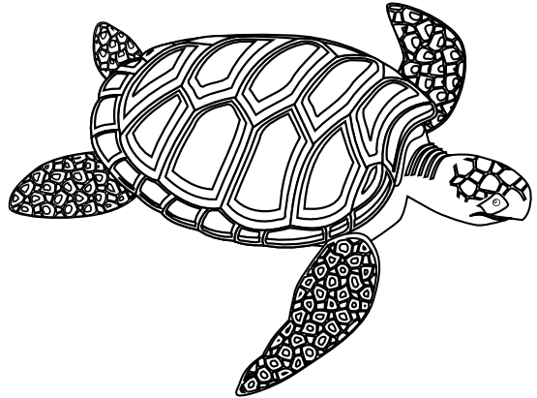
1. Green sea turtles are found in the water around the Perhenthian Islands of Malaysia. Identify one structural adaptation that would help the turtle survive in this watery environment.
2. Green sea turtles are ectothermic. What does this mean?
3. A green sea turtles shell is made up of keratin, the same as fingernails. Underneath the keratin shell is a fine network of capillaries that carry blood and heat to and from the turtle’s body.
(a) Explain how this might help regulate the turtle's body temperature.
(b) Is this a structural, physiological or behavioural adaptation?
4. These turtles often come up the beach during storms to dig a hole to lay their eggs.
(a) What is the advantage of this adaptation?
(b) Is this a structural, physiological or behavioural adaptation?
5. The male turtle is different from the female in several ways. One of which is the presence of claws on their front flippers. Suggest one possible advantage of this adaptation.
6. Green sea turtle hatchlings will often wait in their 1.5 metre deep nest until they feel their brothers and sisters wriggling next to them. Then they all start wriggling to the surface together. Suggest a possible advantage of this behaviour.
7. Once at the surface, the hatchlings move towards the nearest bright light which is usually the moon shining on the surface of the water. Suggest why houses around turtle hatching grounds are banned from using outside lights during the night.

