Investigation 1: Digesting starch

Aim: To investigate the action of an enzyme found in saliva (amylase) on starch.

Materials:
- 3 test tubes  - 1 test tube rack  - 1 rubber stopper to fit test tube  - 1 x 10 mL measuring cylinder  - 3 Pasteur pipettes or droppers  - 3 sticky labels or a marker  - 1 stopwatch | - 1 spotting plate  - 1 dropper bottle of 1% starch solution  - 1 dropper bottle of 10 % glucose solution  - 1 dropper bottle of 1% amylase solution  - 1 dropper bottle of iodine solution  - 3 pieces of glucose test tape or test strips

Method:
- Label the test tubes 1–3.
- Set up the three test tubes as described in the table below.
Test tube | Contents
1 | Half fill the test tube with glucose solution
2 | Half fill the test tube with starch solution
3 | Half fill the test tube with starch solution.  Add 2 mL of amylase solution.
- Add a stopper to test tube 3 and shake to mix the amylase and starch solutions.
- Share the test tubes between the members of your group and hold each test tube in a hand for 10 minutes.
- After 10 minutes, place a few drops of liquid from test tube 1 into two depressions on the plate. Repeat this for test tubes 2 and 3. See diagram 1.
- Test samples from each test tube for the presence of glucose and starch.
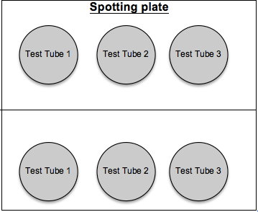
Test for glucose
- Place a piece of test tape or dip a test strip into one of each sample.
- Is glucose present? Check the colour against the key on the packaging.
Test for starch
- Add two drops of iodine to each of one sample.
- Is starch present? If starch is present the solution will go blue/black.
- Record your results.
- Clean up all the equipment as directed by your teacher.
Diagram 1: Solution samples on the spotting plate

Results:
Title: The action of the enzyme amylase on starch
Test tube | Present at the beginning | Present at the end
1 | Glucose
2 | Starch
3 | Starch

Discussion:
- What do your results indicate about the action of the enzyme amylase on starch?

- What is the purpose of including test tubes 1 and 2 in the investigation?

- What is the purpose of holding the test tubes in your hands?

Conclusion:
Use your observations from this investigation to explain the change in texture and taste of the bread you ate at the start of this lesson.

